SITE OVERVIEW: Red rejected site
Town | Paignton
Site Name | Land to the SW of Queen Elizabeth Drive
Site Description | Sloping lad to the SW of Queen Elizabeth Drive. The land appears to be covered in small trees/ bushes with a more open area on the SW boundary, which is a public right of way and prone to flooding .
Total site area (ha) | 0.77ha
Map (if needed)

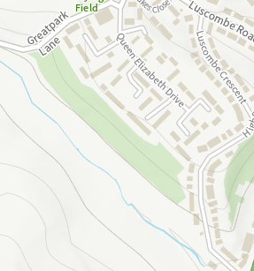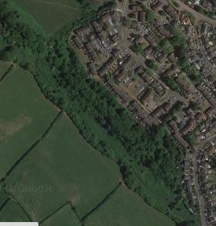

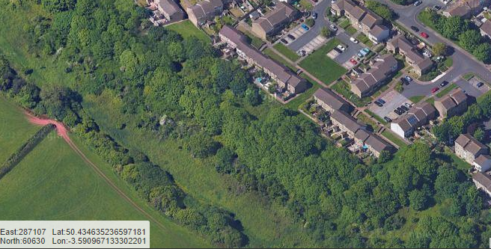

HELAA Reference no. | T851
Approx. yield | 0
Suitable: Previous assessment of suitability | Rejected in 2013 SHLAA. Step site, difficult to access, Adjacent County Wildlife site.  There are flooding issues on the SW boundary.  Site has some archaeological potential. May require programme of archaeological mitigation.
Any Change in circumstances to consider suitable? | The land appears to have become more grown up since 2013, and is largely covere d with greenery. As such its biodiversity value to the adjacent CWS and lanfdscape value separating residential development from the rural hinterland hjas increased.
Available? | Not being promoted in 2021. Access difficulties remain.
Achievable
Customer Reference no.
Current use | Informal woodland.
Assess in 2021 HELAA? | 0

AVAILABILITY ASSESSMENT Does not appear to be suitable and is not being promoted.
The next 5 years | 0
A 6-10 year period
An 11-15 year period
Later than 15 years

