SITE OVERVIEW
Town | Paignton
Site Name | Land at junction of Yalberton Road and Lower Yalberton Road, Paignton
HELAA Reference no. | 21P044
Approx. yield | 6
Suitable | Suitability needs to be assessed. The site is located just outside the Brixham Road Future Growth Area (the western boundary of which is approximately 80m east of the site), is outside of the existing settlement boundary, and while there are some shops and economic land a reasonable distance away, pedestrian links are poor. Relatively sensitive in terms of ecology and heritage.
Available | Yes. The site has been promoted by the landowner through the Call For Sites process.
Achievable | Yes.
Customer Reference no.
Source of Site (call for sites, Local Plan allocation etc.). | Call For Sites
Current use | Agriculture
Site descriptions | Open field on the south side of the junctions between Yalberton Road, Higher Yalberton Road, and Lower Yalberton Road which are narrow lanes with hedgebanks. The land, which hosts a number of trees, slopes downhill towards the north and there are cultivated fields immediately to the east, west and south. Some clearance works have been carried out on site with a gap having been made in the hedgebank at the northeastern corner of the site. There are power cables approximately 70m to the southeast of the site
Total site area (ha) | 0.43
Approx. developable area (ha) | 0.32
Map
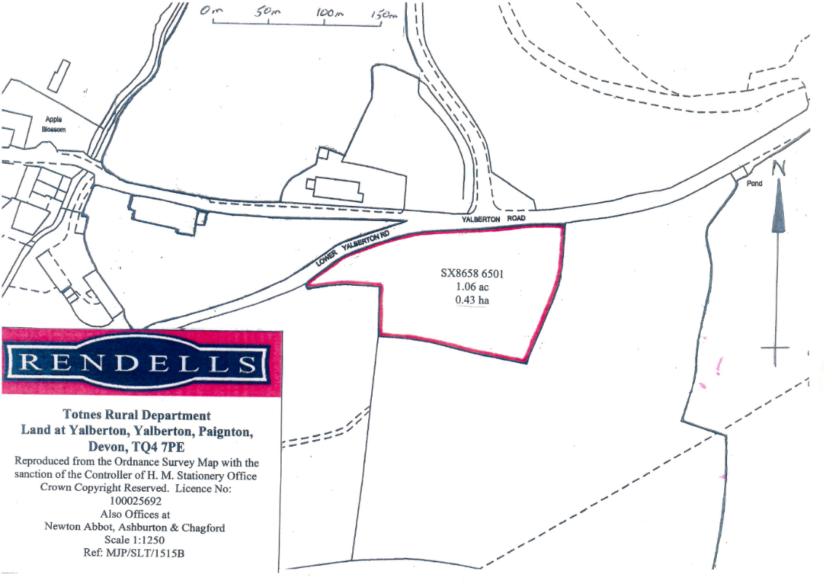
SUITABILITY ASSESSMENT: STAGE A

Strategic potential: | No
Housing? | Yes
Employment? | No
Other Use? | None
Biodiversity- Within SAC/SSSI | No, although site is located within the Sustenance Zone and the Landscape Connectivity Zone of the South Hams SAC for Greater Horseshoe Bats, the Consultation Zone and 250m Buffer Zone for Cirl Buntings, and the Consultation Zone for Greater Crested Newts.
Flood Zone 3b | No, although the northern boundary of the site (i.e. the frontage along Yalberton Road) is in an area of surface water flood risk.
Other NPPF Showstoppers (not policy constraints) | No
Conclusion

SUITABILITY ASSESSMENT: STAGE B

Access | Access from Yalberton Road which is a narrow lane with hedgebanks.
Flood risk, water quality and drainage | The northern boundary of the site (i.e. the frontage along Yalberton Road) is in an area of surface water flood risk.
Heritage and Archaeology (including distance from assets). | Grade II listed buildings including King William Cottage (a thatched cottage approximately 20m from the site on the northern side of Yalberton Road), and buildings at Higher Yalberton Farm including the Cider Barn (approximately 65m to the west) and the Farmhouse and associated buildings (approximately 130m to the west). Large historic stone boundary wall along the northern side of Yalberton Road and western side of Higher Yalberton Road in close proximity to the site.  Archaeology: Potential for medieval archaeology. Requires programme of archaeological mitigation.
Infrastructure | Lack of infrastructure for pedestrians travelling to or from the site.
Landscape | Countryside Area.  Landscape Character Type 3H – Secluded valleys.  Paignton Rural Character Sub-Area 3I (Yalberton Valley, moderately sensitive).  Historic Landscape Character – Orchards.
Ecology | Located within the Sustenance Zone and Landscape Connectivity Zone of the South Hams SAC for Greater Horseshoe Bats.  The entirety of the site is located within the Cirl Bunting Consultation Zone and the western part of the site is located within the Cirl Bunting 250m buffer zone (breeding territory).  Located within the Greater Crested Newt Consultation Zone.  The land to the north of Yalberton Road is designated as a Local Nature Reserve.
Safety related constraints | The narrow lanes with hedgebanks present some concerns with regard to highway safety particularly for pedestrians.  There are power cables approximately 70m to the southeast of the site.
Soils (Agricultural Land classification) and contamination
Local Plan | Policy C1 - Countryside Area, outside of Future Growth Area. (The Brixham Road Future Growth Area is approximately 80m to the east.)
Neighbourhood Plan | PNP1 (a) Rural Character Area, PNP19 Safeguarding open countryside
Development progress (where relevant) | None
Other
HELAA Panel Summary
Site potential

AVAILABILITY ASSESSMENT
Reasonable prospect of delivery (timescale):

The next 5 years | 0
A 6-10 year period
An 11-15 year period
Later than 15 years

