SITE OVERVIEW
Town | Paignton
Site Name | Land North of Coombe Road, Paignton
HELAA Reference no. | 21P036  P0647ZZ, P0647AH & P0647AF
Approx. yield | 14
Suitable | Part of site may be suitable – access, topography and conflict with LP and NP policies
Available | Yes – promoted by TDA
Achievable | Yes
Customer Reference no. | Leave Blank for now
Source of Site (call for sites, Local Plan allocation etc.). | TDA Sites
Current use | Open Space, Woods & Scrub Land
Site descriptions | Open Space, Woods & Scrub Land situated to the north of properties on Coombe Road. Occombe Valley Woods is located to the north of the site.
Total site area (ha) | 2.03
Gross site area (ha)  (approximate developable area) | 0.5
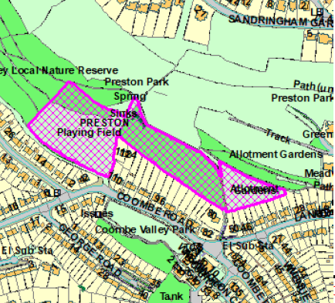
SUITABILITY ASSESSMENT: STAGE A

Strategic potential: | No (less than 50)
Housing? | Yes
Employment? | No
Other Use? | C2, other development associated with outdoor sport and recreation
Biodiversity- Within SAC/SSSI | Policy C1 countryside area - Occombe Valley Woods  Policy NC1 & SS9 – site within LNR (OSWI) - Occombe Woods - Preston Park  Site Adjacent to Occombe Valley LNR and Occombe Valley Woods (Policies SS9 & NC1)  Within Cirl bunting consultation zone  Within S Hams SAC GHB LCZ
Flood Zone 3b | No
Other NPPF Showstoppers (not policy constraints) | Para 97. Existing open space, sports and recreational buildings and land, including playing fields, should not be built on unless 3 tests are met.  170. Planning policies and decisions should contribute to and enhance the natural and local environment by: a) protecting and enhancing valued landscapes, sites of biodiversity or geological value and soils (in a manner commensurate with their statutory status or identified quality in the development plan)  Site not within LGS but adjacent to - Para 101 of the NPPF indicates policies for managing development in LGSs should be consistent with green belts. Para 144. When considering any planning application, local planning authorities should ensure that substantial weight is given to any harm to the Green Belt. ‘Very special circumstances’ will not exist unless the potential harm to the Green Belt by reason of inappropriateness, and any other harm resulting from the proposal, is clearly outweighed by other considerations.
Conclusion | Sensitively designed development of a part of the site only could be suitable due to the significant constraints. Mitigation/compensation would be required.

SUITABILITY ASSESSMENT: STAGE B

Access | Difficult – appears very limited access into the site – possibly via Occombe Valley Road rear, private road
Flood risk, water quality and drainage | N/A
Heritage and Archaeology (including distance from assets). | No significant heritage constraints.  Archaeological potential needs to be assessed and evaluated.
Infrastructure | Access would need improvement
Landscape | Preston Park LCA - Moderately Sensitive - Conserve
Ecology | Policy C1 countryside area - Occombe Valley Woods  Policy NC1 & SS9 – site within LNR (OSWI) - Occombe Woods - Preston Park  Site Adjacent to Occombe Valley LNR and Occombe Valley Woods (Policies SS9 & NC1)  Site within rural character area - Policy PNP1a.  Site is adjacent to Lower Penns Road Allotments - Local Green space PLGS.24 - Policy PNP1b.  Within Cirl bunting consultation zone – mitigation required  Within S Hams SAC GHB LCZ – mitigation required
Safety related constraints | N/A
Soils (Agricultural Land classification) and contamination | N/A
Local Plan | Policy C1 countryside area - Occombe Valley Woods. In the open countryside, away from existing settlements, and in rural areas surrounding the three towns of Torbay, development will be resisted where this would lead to the loss of open countryside or creation of urban sprawl, or where it would encourage the merging of urban areas and surrounding settlements to the detriment of their special rural character and setting.  Policy NC1 - LNR (OSWI) - Occombe Woods - Preston Park  Adjacent to Occombe Valley LNR and Occombe Valley Woods (Policies SS9 & NC1)
Neighbourhood Plan | Policy PNP1a - PLGS.24 Local Green space (adjacent to LGS)  Policy PNP1b - Rural character area  Policy PNP19 - safeguarding open countryside - In the Rural Character Area…it is essential to retain the existing rural and landscape character, including its amenities, during the period of the Plan development proposals will be supported where they are in conformity with the National Planning Policy Framework, Policy C1 of the Torbay Local Plan and PNP1.
Development progress (where relevant) | No
Other | Steep site – also increases visual impact as any development would be above the existing built-up area.
HELAA Panel Summary | To be completed later
Site potential | Leave blank until after HELAA Panel

AVAILABILITY ASSESSMENT
Reasonable prospect of delivery (timescale):
The next 5 years
A 6-10 year period | 15
An 11-15 year period
Later than 15 years

