SITE OVERVIEW Rejected site – retain as employment use
Town | Paignton
Site Name
Site Description | Council Depot, South of Borough Road Yalberton.
Total site area (ha) | 2.97
Map (if needed)
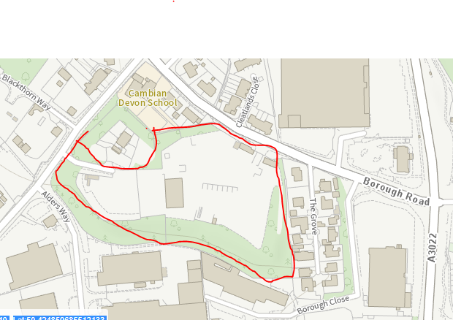

HELAA Reference no. | 21P032 2013 SHLAA T826
Approx. yield | 0
Suitable: Previous assessment of suitability | Previously considered suitable for 40 dwellings in 2013 SHLAA. However, the site is in employment use and if it were to be developed, employment use is more likely to be suitable.
Any Change in circumstances to consider suitable? | TDA’s concerns about lack of employment sites in Torbay. HELAA Panel did not consider site particularly suitable for housing – potential contamination and amenitry issues. Employment use is more appropriate.
Available? | Not being actively promoted by Torbay Council.
Achievable
Customer Reference no.
Current use
Assess in 2021 HELAA? | As employment land.

AVAILABILITY ASSESSMENT
Reasonable prospect of delivery (timescale):
Unlikely to come forward
The next 5 years | 0
A 6-10 year period
An 11-15 year period
Later than 15 years

