SITE OVERVIEW: Red rejected site
Town | Brixham Peninsula
Site Name | Alston Lane
Site Description | 13261
Total site area (ha) | 0.55
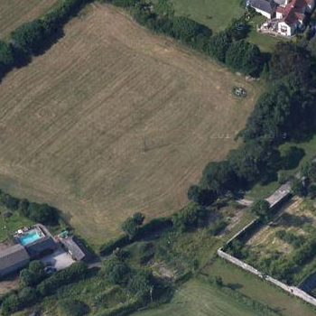
HELAA Reference no. | 13260
Approx. yield
Suitable: Previous assessment of suitability | Abuts AONB, Undeveloped Coast, Conservation Area. Trees on frontage with Alston Lane.  Impact on setting of Lupton Park.
Any Change in circumstances to consider suitable? | Constraints identified in 2013 remain relevant
Available?
Achievable
Customer Reference no.
Current use
Assess in 2021 HELAA? | Not suitable: loss of tress and impact on AONB

AVAILABILITY ASSESSMENT
Reasonable prospect of delivery (timescale):

Confirmation of availability needed from owners.
The next 5 years
A 6-10 year period
An 11-15 year period
Later than 15 years

