SITE OVERVIEW Red Rejected
Town | Brixham Peninsula/ BCG Villages
Site Name | Land to the east of Brokenbury Quarry Waste Water Treatment Works (WWTW).
Map (if needed)
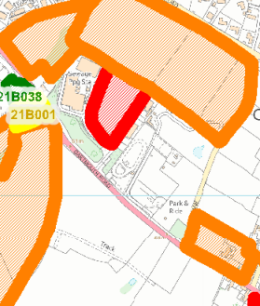

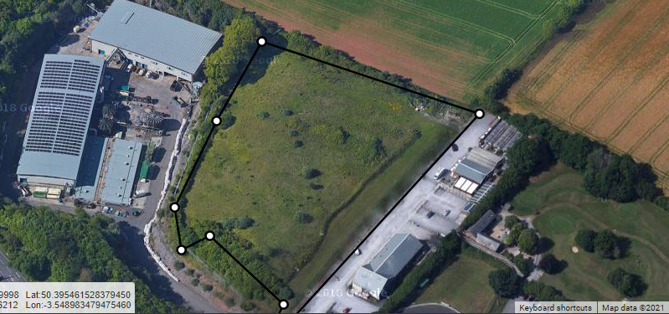

Allocation or HELAA Reference no. | 21B051 Land East of Brokenbury Quarry
Approx. yield | 0
Suitable: How the principle of development is established | May be required for ecological mitigation or future infrastructure for Brokenbury Quarry WWTW.  Site is between the waste water treatment works and servicing area for the farm shop, so unlikely to be suitable for residential use, even if acceptable of ecological grounds.
Available: Any change in circumstances since principle established | Has not been actively promoted. Development could jeopardise the long term operation/ expansion of the WWTW.
Achievable | Proximity to WWTW likely to affect achievability for residential. May be achievable as employment.
Customer Reference no.
Current use | Scrubland/ SWW mitigation/  safeguarded area.
Site description | Land to the east of Brokenbury Quarry WWTW, and accessed from the WWTW service road. The land appears to be mitigation or safeguarded land by South West Water.
Total site area (ha) | 1.3ha

AVAILABILITY ASSESSMENT
Reasonable prospect of delivery (timescale):

May be suitable for employment or infrastructure expansion (in association with SWW), but unlikely to be suitable or achievable for residential.

Confirmation of availability needed from owners.
The next 5 years | 0
A 6-10 year period
An 11-15 year period
Later than 15 years

