SITE OVERVIEW Broad Location -rejected
Town | BCG Villages/ Brixham Peninsula
Site Name | Steam Fair site and surrounding SE and NW of Kennels Road
Map (if needed)

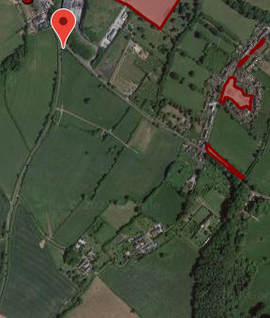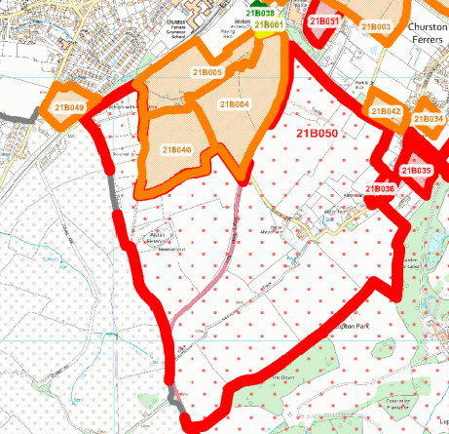

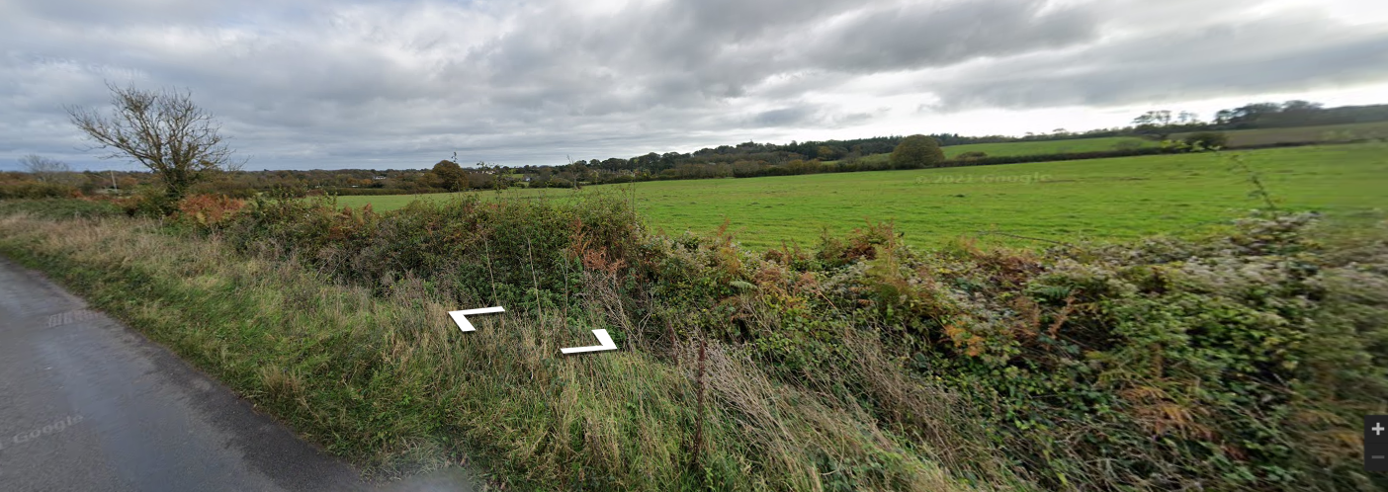

Allocation or HELAA Reference no. | 21B050
Approx. yield | 0
Suitable: How the principle of development is established | Sloping greenfield land forming rural hinterland between Torbay and South Devon AONB. The AONB and Churston Conservation Area lie close to the SE and the SE side of the site is also Flood Risk Zone 3. The north of the area is Mineral Safeguarding Area.  Most of the area is AOLC 1P Rolling Farmland- Highly sensitive, conserve and enhance in the 2010 Landscape Character Assessment.  Likely impact on greater horseshoe bat sustenance zone.  Harm to tourism.  The area is unconnected to any settlement.  Note that the land to the NW of Kennels Road has not been rejected outright. Although it has significant constraints it is further from the AONB/CA and closer to the settlement of Galmpton than the land to the SE of Kennels Road.
Available: Any change in circumstances since principle established | Has not been actively promoted
Achievable | Likely to be viable for housing development. There would be significant infrastructure requirements.
Customer Reference no.
Current use | Agriculture
Site description | Broad Location to the SE of Kennels Lane running down to Brixham Road to the north of the site. Alston Lane runs across the site.
Total site area (ha) | Broad Location circa 25 ha.

AVAILABILITY ASSESSMENT
Reasonable prospect of delivery (timescale): Large proportion of the land will impact upon the Rural settlement gap, Lupton Park setting and AONB. Loss of Grade 2 agricultural Land.

Confirmation of availability needed from owners.
The next 5 years | 0
A 6-10 year period
An 11-15 year period
Later than 15 years

