SITE OVERVIEW
Town | Brixham
Site Name | South of St Marys Bay to Sharkham Point
Map (if needed)

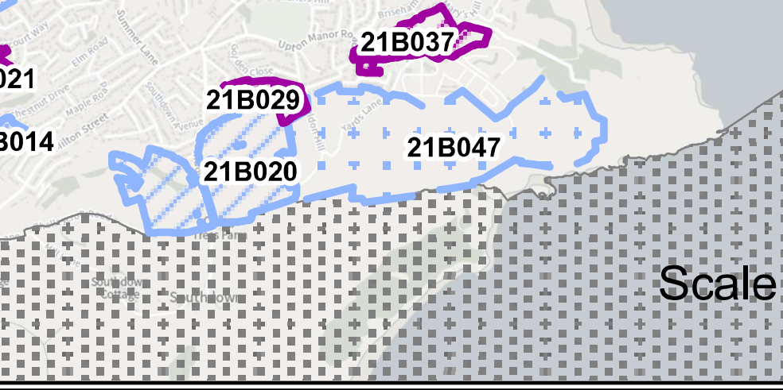

Allocation or HELAA Reference no. | 21B047
Approx. yield | 0
Suitable: How the principle of development is established | Not suitable for development. AONB and undeveloped coast. Close to South Hams SAC, NNR and special policy area: serious damage to ecology.
Available: Any change in circumstances since principle established | Not clear – but not suitable
Achievable | Development is likely to be viable but significant access and infrastructure issues. Land is very steep which will reduce viability.
Customer Reference no.
Current use | Holiday/coastal slopes
Site description | Countryside to the south of St Marys Road, Brixham. The east of the area is South Bay Holiday Park, and the west is open countryside, but very steep.
Total site area (ha) | Broad Location

AVAILABILITY ASSESSMENT
Reasonable prospect of delivery (timescale):
Not suitable for development due to serious landscape and ecological harm.

The next 5 years | 0
A 6-10 year period
An 11-15 year period
Later than 15 years

