SITE OVERVIEW
Town | Brixham/BCG Villages
Site Name | Lupton Park Estate to Monksbridge
Map
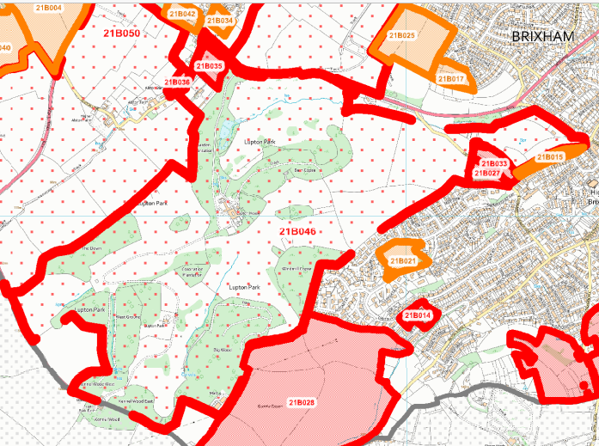

Allocation or HELAA Reference no. | 21B046
Approx. yield
Suitable: How the principle of development is established | Not suitable. Major development in the AONB. Historic Park and Garden. The area is close to South Hams SAC and there would be harm to the greater horseshoe bat sustenance zone. Loss of trees and other ecological harm.
Available: Any change in circumstances since principle established | Does not appear to be available. Lupton House is a Grade 2* Listed Building and in use as a conference centre/ wedding venue.
Achievable | Likely to be viable, but significant topographical issues and need for infrastructure will reduce viability. Windy Corner is a significant constraint. Harm to Landscape and Historic Park and Garden.
Customer Reference no.
Current use | Lupton House is run as a charitable Community event space. Gardens are largely private residential.
Site description | Land around Lupton House, Lupton Park extending to Monksbridge in the East.
Total site area (ha) | Broad Location

AVAILABILITY ASSESSMENT
Reasonable prospect of delivery (timescale):
Not suitable as a broad location for major development due to historic environment, ecology and landscape (AONB issues).

Confirmation of availability needed from owners.
The next 5 years | 0
A 6-10 year period | 0
An 11-15 year period | 0
Later than 15 years | 0

