SITE OVERVIEW Red Broad Location
Town | Brixham/ BCG Villages
Site Name | Churston Barony Broad Location
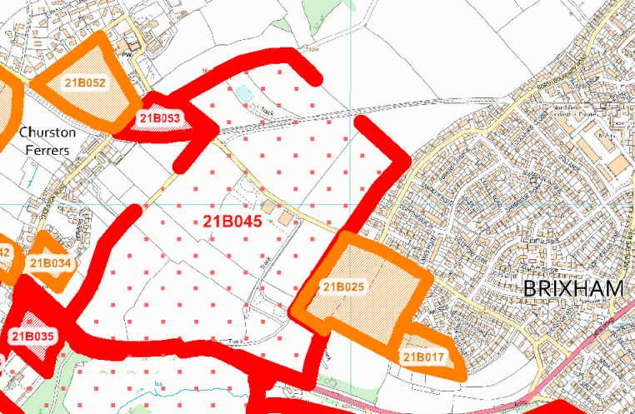
Allocation or HELAA Reference no. | 21B045
Approx. yield
Suitable: How the principle of development is established | Would constitute major rural development in the AONB. Would significantly urbanise the gap between Churston and Brixham, and serious coastal landscape impact. The area is lose to the South Hams SAC and there would be likely impacts on greater horseshoe bat flight paths and sustenance zone.
Available: Any change in circumstances since principle established | Likely to be available if alocated.
Achievable | Would probably be viable if allocated due to coastal location. But there are major road infrastructure constraints and significant site servicing would be needed. The pinch point at Windy Corner is a significant constraint.
Customer Reference no.
Current use | Agriculture
Site description | Land to the NE of Higher Boundary Road Brixham, extending to Churston Ferrers Village.
Total site area (ha) | Broad Location

AVAILABILITY ASSESSMENT
Reasonable prospect of delivery (timescale):
Not suitable for major development due to landscape impact on AONB, coastal impact and impact on Greater Horseshoe Bat sustenance zone.
Note that smaller sites are assessed as 21B025 and 21B017.

Confirmation of availability needed from owners.
The next 5 years | 0
A 6-10 year period
An 11-15 year period
Later than 15 years

