SITE OVERVIEW: Red rejected site
Town | Brixham/BCG Villages
Site Name | Broad Locations: Broadsands
Map (if needed)

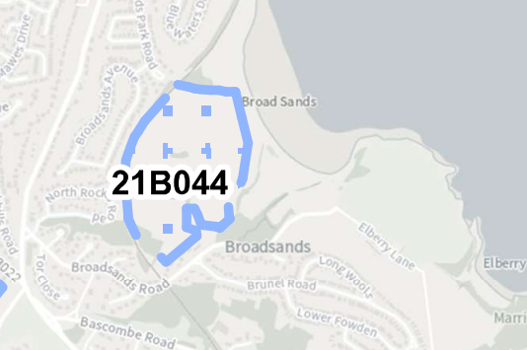

Allocation or HELAA Reference no. | 21B044
Approx. yield
Suitable: How the principle of development is established | Only a smaller area coded as 21B048 likely to be potentially developable, and even this has coastal landscape constraints.  Development of the broader area would have a significant effect on the undeveloped coast, county wildlife site and is impacted by flood risk and coastal change issues. There would be ham to Broadsands Barrow which is a Scheduled Monument.  Land to the West around Elbury Lane is AONB.  Minerals safeguarding Area.  Access would be difficult as it would need to come through Broadsands Road.
Available: Any change in circumstances since principle established | Land is mainly council owned, but not suitable for strategic development as noted above.
Achievable | Significant infrastructure constraints related to the coastal zone.
Customer Reference no.
Current use | Agricultural, tourism, car park
Site description | Broad location to the East of Paignton and Dartmouth Stream Railway, Broadsands Road and Broadsands Beach/Chrurston Point.
Total site area (ha) | Broad Location

AVAILABILITY ASSESSMENT
Reasonable prospect of delivery (timescale): Not suitable as a broad location. See 21B048 for the only part of the broad area that may have potential, but even this smaller area has significant constraints.

The next 5 years | 0
A 6-10 year period
An 11-15 year period
Later than 15 years

