SITE OVERVIEW Brixham (BCG) Red site
Town | Brixham /Churston
Site Name | Piggery/Hayes Court
HELAA Reference no. | 21B042
Approx. yield | 10
Suitable | No – Flood Zone 3
Available | Not promoted
Achievable | Would be attractive to developers but flooding and landscape issues
Customer Reference no. | 13262 in 2013 SHLAA
Source of Site (call for sites, Local Plan allocation etc.). | Knowledge site (Rejected in 2013 SHLAA 13262)
Current use | Paddock/orchard
Site descriptions | House and grounds NE side of Brixham Road, adjacent to Churston Cross
Total site area (ha) | 1.26
Gross site area (ha)
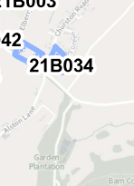

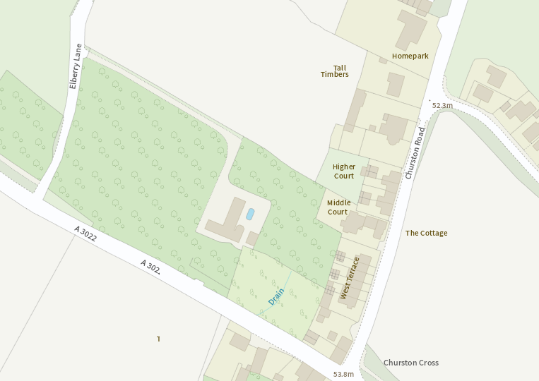

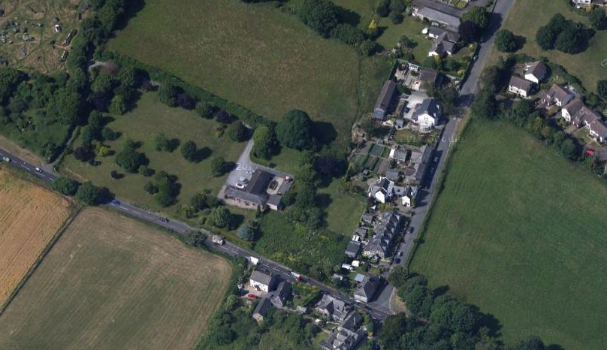

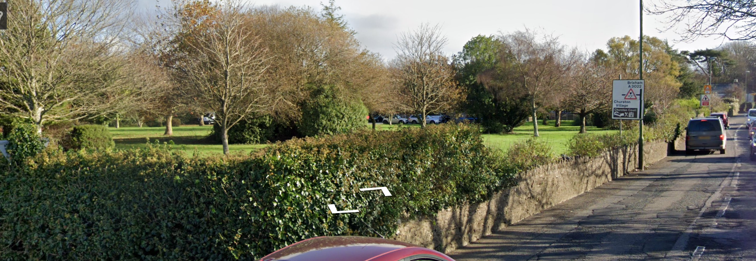

SUITABILITY ASSESSMENT: STAGE A

Strategic potential: | No
Housing? | No
Employment? | No
Other Use?
Biodiversity- Within SAC/SSSI | Greater Horseshoe bat sustenance zone.
Flood Zone 3b | Floodzone 3
Other NPPF Showstoppers (not policy constraints) | Close to AONB Boundary
Conclusion

SUITABILITY ASSESSMENT: STAGE B

Access | Existing access onto Brixham Road
Flood risk, water quality and drainage | Flood risk zone 3.
Heritage and Archaeology (including distance from assets). | Would need investigation. The site is within the Churston Conservation Area.
Infrastructure
Landscape | Close to boundary. Loss of trees and impact in street scene.
Ecology | Greater Horseshoe Bat sustenance zone
Safety related constraints | No
Soils (Agricultural Land classification) and contamination | Not in agricultural use
Local Plan | Countryside Area
Neighbourhood Plan
Development progress (where relevant) | No
Other
HELAA Panel Summary | Post panel addition.
Site potential

AVAILABILITY ASSESSMENT
Reasonable prospect of delivery (timescale):

The next 5 years | 0
A 6-10 year period
An 11-15 year period
Later than 15 years

