SITE OVERVIEW: Red rejected site
Town | BCG Area – abutting Brixham
Site Name | NE of Laywell Road Brixham
HELAA Reference | 21B033
Site Description | Land NE of Laywell Road, Brixham
Total site area (ha) | 1.43
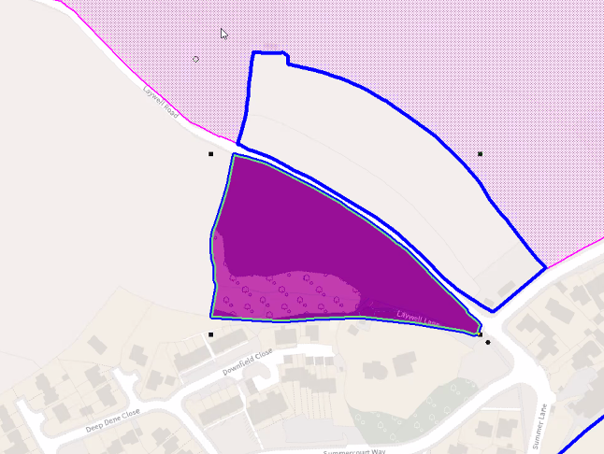
Approx. yield | 0
Suitable: Previous assessment of suitability | Site is within the AONB  Rejected by 2013 SHLAA: impact on AONB and greater Horseshoe Bat Sustenance Zone  Archaeology: Medieval field system. Archaeological potential. May require programme of archaeological mitigation.
Any Change in circumstances to consider suitable? | No
Available?
Achievable
Customer Reference no.
Current use
Assess in 2021 HELAA?

AVAILABILITY ASSESSMENT
Reasonable prospect of delivery (timescale):
Not suitable- landscape impact.

The next 5 years | 0
A 6-10 year period
An 11-15 year period
Later than 15 years

