SITE OVERVIEW: Red rejected site
Town | Brixham
Site Name | Lupton Park / Guzzle Down
Site Description
Total site area (ha) | 38.3
Map (if needed)
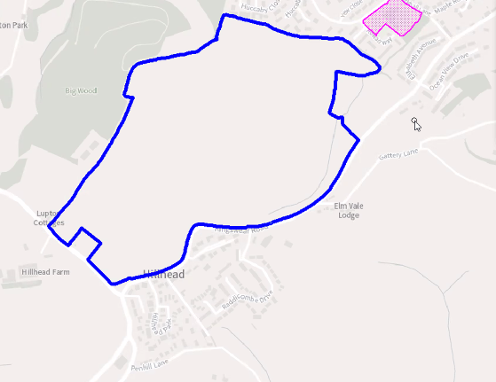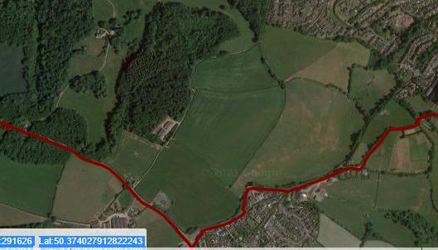

HELAA Reference no. | T719a
Approx. yield | 0
Suitable: Previous assessment of suitability | No. Rejected in 2013 SHLAA. Would be major development with the AONB (tests of para 172 of the NPPF apply).  Access is not easy from Brixham, so major highway works would be needed (e.g. to connect to A379 and upgrading of Kingswear Road )  Greater Horseshoe bat sustenance zone.  A scheme of at least 500 dwellings is likely to be needed; which would have a major harmful environmental impact.  Archaeology: Impact on Lupton Park Registered Park/Garden needs to be assessed. Alleged site of Roman camp, or possibly earlier defensive earthworks. Needs pre-determination archaeological evaluation.
Any Change in circumstances to consider suitable? | No
Available?
Achievable
Customer Reference no.
Current use | Agriculture (grade 3)
Assess in 2021 HELAA? | Not suitable

AVAILABILITY ASSESSMENT
Reasonable prospect of delivery (timescale):

The next 5 years | 0
A 6-10 year period
An 11-15 year period
Later than 15 years

