SITE OVERVIEW: Red rejected site
Town | Brixham Town
Site Name | Washbourne Close Green
HELAA Reference no. | 21B024  E5-E21
Approx. yield | 6
Suitable
Available
Achievable
Customer Reference no. | Leave Blank for now
Source of Site (call for sites, Local Plan allocation etc.). | POS Bxm
Current use | Public open space
Site descriptions | Field situated to the north of Washbourne Close
Total site area (ha) | 0.24
Gross site area (ha)  (approximate developable area) | 0.24
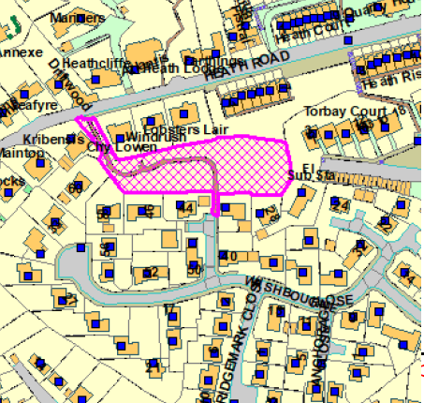
SUITABILITY ASSESSMENT: STAGE A

Strategic potential: | No (less than 50)
Housing? | Yes
Employment? | No
Other Use? | C2
Biodiversity- Within SAC/SSSI | Within South Hams SAC GHB LCZ and SZ
Flood Zone 3b | No
Other NPPF Showstoppers (not policy constraints) | Para 97. Existing open space, sports and recreational buildings and land, including playing fields, should not be built on unless 3 tests are met.
Conclusion | Could only be considered if 3 tests of para 97 met and suitable replacement POS could be found.

SUITABILITY ASSESSMENT: STAGE B

Access | Washbourne Close – narrow
Flood risk, water quality and drainage | No
Heritage and Archaeology (including distance from assets). | Within 15m Brixham Town CA
Infrastructure | Drainage, access
Landscape | N/A
Ecology | Within South Hams SAC GHB LCZ and SZ.  Within cirl bunting consultation zone  Urban setting likely to limit impacts on GHB or cirl bunting
Safety related constraints | No
Soils (Agricultural Land classification) and contamination | N/A
Local Plan | SDB2
Neighbourhood Plan | Policy E5 public open space – assessed according to para 97 of NPPF
Development progress (where relevant) | No
Other
HELAA Panel Summary | To be completed later
Site potential | Leave blank until after HELAA Panel

AVAILABILITY ASSESSMENT
Reasonable prospect of delivery (timescale):

The next 5 years | 6
A 6-10 year period
An 11-15 year period
Later than 15 years

