SITE OVERVIEW: Red rejected site
Town | Brixham Town
Site Name | Parkham Field, Parkham Lane
HELAA Reference no. | 21B022  E5 – E13
Approx. yield | 6
Suitable
Available
Achievable
Customer Reference no. | Leave Blank for now
Source of Site (call for sites, Local Plan allocation etc.). | POS Bxm
Current use | POS
Site descriptions | Field and woods in use as POS
Total site area (ha) | Approx. 0.8
Gross site area (ha)  (approximate developable area) | 0.64
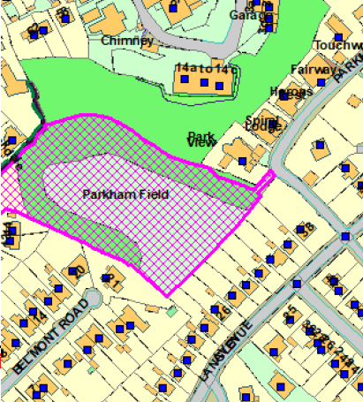
SUITABILITY ASSESSMENT: STAGE A

Strategic potential: | No
Housing? | Yes
Employment? | No – adjacent to site identified in NP as committed employment site
Other Use? | C2
Biodiversity- Within SAC/SSSI | In South Hams SAC GHB LCZ and SZ
Flood Zone 3b | No
Other NPPF Showstoppers (not policy constraints) | Para 97. Existing open space, sports and recreational buildings and land, including playing fields, should not be built on unless 3 tests are met.
Conclusion | Could only be considered if 3 tests of para 97 met and suitable replacement POS could be found.

SUITABILITY ASSESSMENT: STAGE B

Access | Footpath off Parkham Lane provides access into the field bound by residential properties and widening may require encroachment into private property – remaining boundaries formed by private property or steep with no clear means of access for vehicles.
Flood risk, water quality and drainage | No
Heritage and Archaeology (including distance from assets). | No significant heritage constraints.  Archaeology: Former quarries. Possible caves. May require assessment to inform possible archaeological mitigation.
Infrastructure | Access, drainage
Landscape | N/A
Ecology | Within South Hams SAC GHB LCZ and SZ.  Within cirl bunting consultation zone – urban setting likely to limit impacts
Safety related constraints | No
Soils (Agricultural Land classification) and contamination | N/A
Local Plan | Policy C5 - Development only permitted where It does not undermine the value of the ULPA as an open or landscaped feature within the  urban area; and It makes a positive contribution to the urban environment and enhances the landscape character of the ULPA.  NC1 – Biodiversity and Geodiversity  Policy SS8 – Natural Environement
Neighbourhood Plan | Policy E5 public open space – assessed according to para 97 of NPPF  Adjacent to NP committed employment site J1 - 4.
Development progress (where relevant) | No
Other
HELAA Panel Summary | To be completed later
Site potential | Leave blank until after HELAA Panel

AVAILABILITY ASSESSMENT
Reasonable prospect of delivery (timescale):
The next 5 years
A 6-10 year period | 6
An 11-15 year period
Later than 15 years

