SITE OVERVIEW: Red rejected site
Town | Brixham
Site Name | Chiseldown Farm
HELAA Reference no. | 21B020
Approx. yield | 100
Suitable | Yes – part of site – conflict with LP and NP Policies
Available | Yes
Achievable | Yes
Customer Reference no. | Leave Blank for now
Source of Site (call for sites, Local Plan allocation etc.). | Call for sites
Current use | Agricultural Land
Site descriptions | Two parcels of agricultural land, one to the north of Yards Lane and one to the north of Challeycroft Road. The land is divided into a number of fields and ground levels are significantly higher at the southern end of the site which is elevated above Brixham.
Total site area (ha) | 18.71ha
Gross site area (ha) | 5ha (Topography, SAC, Cirl Bunting)
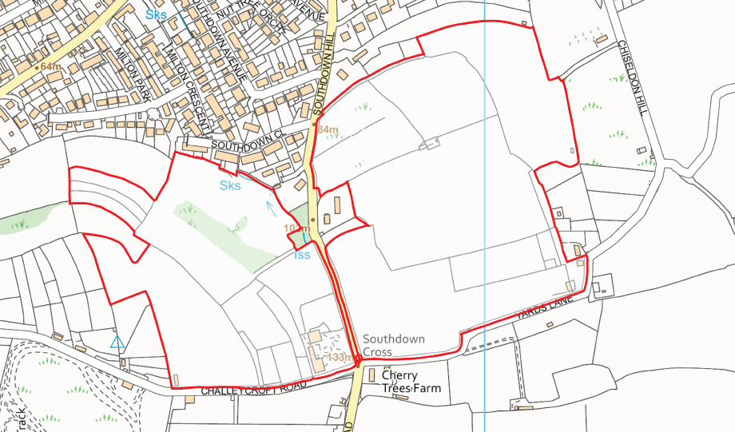
SUITABILITY ASSESSMENT: STAGE A

Strategic potential: | Yes
Housing? | Yes
Employment? | No due to visual prominence and location adjacent to AONB.
Other Use? | Tourism
Biodiversity- Within SAC/SSSI | Yes – within South Hams SAC GHB LCZ and SZ, within open countryside. Within Cirl Bunting consultation zone and breeding territory. Mitigation/compensation would be required. Entire site is within local nature reserve Southdown And Woodhuish.
Flood Zone 3b | No
Other NPPF Showstoppers (not policy constraints) | Para 172. Great weight should be given to conserving and enhancing landscape and scenic beauty in National Parks, the Broads and Areas of Outstanding Natural Beauty.  170. Planning policies and decisions should contribute to and enhance the natural and local environment by: a) protecting and enhancing valued landscapes, sites of biodiversity or geological value and soils (in a manner commensurate with their statutory status or identified quality in the development plan)
Conclusion | Development of a part of the site only could be suitable due to the significant constraints. Mitigation would be required. Not clear whether this could be achieved without harming the SAC.

SUITABILITY ASSESSMENT: STAGE B

Access | Southdown Hill, unclassified road, narrow single track.
Flood risk, water quality and drainage | N/A
Heritage and Archaeology (including distance from assets). | Archaeology: North-west area of site includes well preserved medieval stripfields/lynchets that are a significant historic landscape feature warranting preservation. The system is less intact across the remainder of the site but warrants assessment to inform any retention of further boundaries.
Infrastructure | Highways improvements for access. Drainage, sewage.
Landscape | Adjacent to the AONB  LCA landscape types – Rolling farmland and open coastal plateau  Area of Local Character: 1Q and 5f.  Both AGLV and rated highly sensitive with a management strategy of enhance.
Ecology | The site falls within the Southdown And Woodhuish Local Nature Reserve (Policy NC1).  Located within GHB SZ and LCZ – a number of radio tracked flight paths through site – GHB mitigation will be required. Located within a Cirl bunting breeding territoriy - mitigation will be required.
Safety related constraints | N/A
Soils (Agricultural Land classification) and contamination | Grade 2, 3b and 4 soils present
Local Plan | NC1 Local Nature Reserve, C1 (countryside area),  SS8 - (development in AONB only permitted in exceptional circumstances where a significant public benefit can be demonstrated.) SS2 - outside built up area or Future Growth Area  Part of site lies within SDB3.2 Brixham urban fringe and AONB
Neighbourhood Plan | Policy E2 – site outside of settlement boundary.
Development progress (where relevant) | No
Other | A public right of way runs through the parcel of land to the east of Southdown Hill Road.
HELAA Panel Summary | To be completed later
Site potential | Leave blank until after HELAA Panel

AVAILABILITY ASSESSMENT
Reasonable prospect of delivery (timescale):
The next 5 years
A 6-10 year period | 62
An 11-15 year period | 38
Later than 15 years

