SITE OVERVIEW: Red rejected site
Town | CGB
Site Name | Galmpton Memorial Playing Field
HELAA Reference no. | 21B018  E5-E26
Approx. yield | 30
Suitable | Yes
Available
Achievable | Yes
Customer Reference no. | Leave Blank for now
Source of Site (call for sites, Local Plan allocation etc.). | POS Bxm
Current use | Churston Ferrers Grammar School Playing fields. Galmpton United FC ground?
Site descriptions | Playing field located adjacent to the Greenway Rd/Dartmouth Rd junction. The field’s northern and western boundaries are formed by residential properties.
Total site area (ha) | 1.5
Gross site area (ha)  (approximate developable area) | 1.2
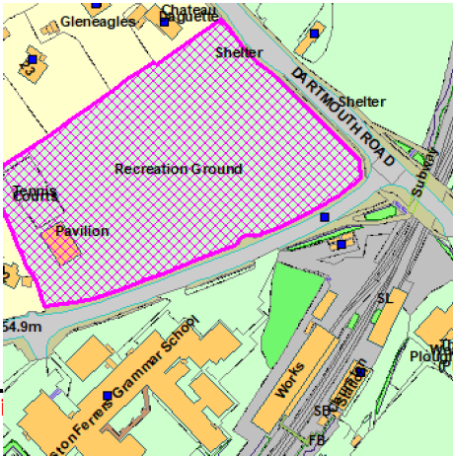
SUITABILITY ASSESSMENT: STAGE A

Strategic potential: | No (less than 50)
Housing? | Yes
Employment? | No.
Other Use? | C2, D2, D1
Biodiversity- Within SAC/SSSI | Within South Hams SAC GHB LCZ and SZ  Within cirl bunting consultation zone  Closer to the rural area - use as playing field limits suitability but hedgerows on site could provide habitat
Flood Zone 3b | No
Other NPPF Showstoppers (not policy constraints) | Para 97. Existing open space, sports and recreational buildings and land, including playing fields, should not be built on unless 3 tests are met.  170. Planning policies and decisions should contribute to and enhance the natural and local environment by: a) protecting and enhancing valued landscapes, sites of biodiversity or geological value and soils (in a manner commensurate with their statutory status or identified quality in the development plan)
Conclusion | Could only be considered if 3 tests of para 97 met and suitable replacement POS could be found. School has alternative playing fields, these could be improved to replace the existing field with higher quality provisions.  Ecology mitigation/compensation may be required.

SUITABILITY ASSESSMENT: STAGE B

Access | Existing access point via Greenway Road (c-road) site also adjoined by Dartmouth Rd (A-road)
Flood risk, water quality and drainage | No
Heritage and Archaeology (including distance from assets). | No significant heritage constraints.  Archaeology: Archaeological potential. May require programme of archaeological mitigation.
Infrastructure | Crossings for road, drainage, access, sewage
Landscape | N/A – urban area
Ecology | Within South Hams SAC GHB LCZ and SZ  Within Cirl Bunting consultation zone  Close to the rural area/edge of village envelope - use as playing field limits suitability but hedgerows on site could provide habitat
Safety related constraints | No
Soils (Agricultural Land classification) and contamination | Poor
Local Plan | C1 – within village envelope  SS1 – within strategic delivery area
Neighbourhood Plan | Policy E5 public open space – assessed according to para 97 of NPPF  BH5 – within town/village area
Development progress (where relevant) | No
Other
HELAA Panel Summary | To be completed later
Site potential | Leave blank until after HELAA Panel

AVAILABILITY ASSESSMENT
Reasonable prospect of delivery (timescale):
The next 5 years
A 6-10 year period | 30
An 11-15 year period
Later than 15 years

