SITE OVERVIEW: Red rejected site
Town Brixham
Site Former Chestnut Primary School (Now Mayfield School), Chestnut Avenue, Brixham
HELAA Reference no. | 21B014
Customer Reference no. | Leave Blank for now
Source of Site (call for sites, Local Plan allocation etc.).
Current use
Site descriptions
Total site area (ha)
Gross site area (ha)
Approx. yield | The Site is in use as part of Mayfield School and therefore not availabkle for housing.
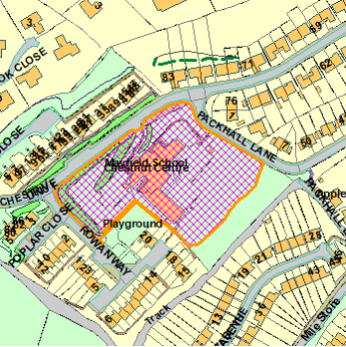
SUITABILITY ASSESSMENT: STAGE A

Strategic potential: 50+ dwellings
Housing?
Employment? | B Class
Other Use? | Retail/G&T/C2
Biodiversity- Within SAC/SSSI
Flood Zone 3b
Other NPPF Showstoppers (not policy constraints)
Conclusion

SUITABILITY ASSESSMENT: STAGE B

Access | Commentary
Flood risk, water quality and drainage | LP
Heritage and Archaeology (including distance from assets). | LP – CA/close to Listed Building/SAM etc
Infrastructure | Highways:  Education: IF PARTICULAR ISSUE eg C St M Sewer issue
Landscape | Landscape Sensitivity Level – AONB/ULPA/LCA
Ecology | LP – OSWI/CWS/SSSI etc. GHB/Cirl Buntings Sustenance Zone/Pinch Points
Safety related constraints | None?  High Voltage Power Line (Edginswell)
Soils (Agricultural Land classification) and contamination | MapInfo/Maps (can do retrospectively
Local Plan | If relevant policy
Neighbourhood Plan | If relevant policy
Development progress (where relevant) | Any planning apps
Other
HELAA Panel Summary | To be completed later
Site potential | Not available

AVAILABILITY ASSESSMENT

The site promoter(s) has confirmed that the site will be available for development within:
The next 5 years
A 6-10 year period
An 11-15 year period
Later than 15 years

