SITE OVERVIEW - GREEN
Town | Torquay
Site Name | 15 Avenue Road, Torquay
HELAA Reference no. | 21T162
Approx. yield | 7
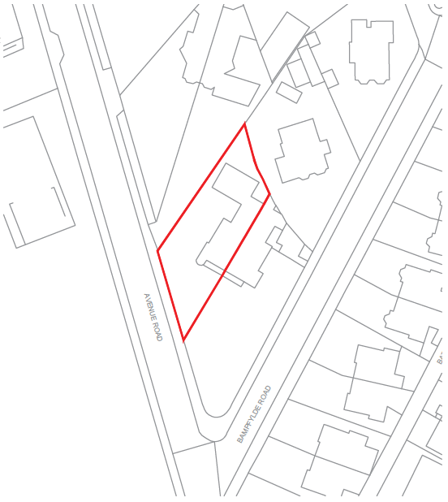
Suitable: How the principle of development is established | P/2021/0157 - Change of use from existing mixed use dwelling and holiday let accommodation (sui generis) and subdivision to ten supported living accommodation units. Approved in July 2021.
Available: Any change in circumstances since principle established | Yes. Very recent permission.
Achievable | Yes.
Customer Reference no.
Source of Site (call for sites, Local Plan allocation etc.). | Post Panel Additions.
Current use | Residential (dwellinghouse and 2 apartments) and tourist accommodation (3 holiday apartments).
Site description | Double-storey (with lower ground floor level), semi-detached, Victorian villa and its curtilage, located on Avenue Road and close to the junction with Bampfylde Road.
Total site area (ha) | 0.09ha

AVAILABILITY ASSESSMENT
Reasonable prospect of delivery (timescale):

The next 5 years | 7
A 6-10 year period
An 11-15 year period
Later than 15 years

