SITE OVERVIEW - GREEN
Town | Torquay
Site Name | 30-34 The Terrace
HELAA Reference no. | 21T161
Approx. yield | 12
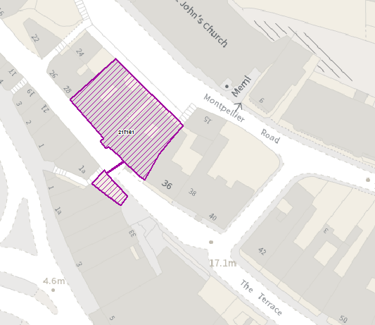
Suitable: How the principle of development is established | The site has planning permission for conversion from offices to 12 residential apartments – see P/2020/0999
Available: Any change in circumstances since principle established | Given that the permission was granted on 12 March 2021 it would appear that the site is available.
Achievable
Customer Reference no.
Current use | Solicitors Offices
Site description | The site comprises a terrace of three, triple-storey buildings which are Grade II listed, in a location just off the lower end of Fleet Street in Torquay’s town centre. This is also a Conservation Area and within a Community Investment Area.
Total site area (ha) | Approximately 0.06ha.

AVAILABILITY ASSESSMENT
Reasonable prospect of delivery (timescale):

Very recent permission
The next 5 years | 12
A 6-10 year period
An 11-15 year period
Later than 15 years

