SITE OVERVIEW - GREEN
Town | Torquay
Site Name | Watcombe Hall, Watcombe Beach Road
HELAA Reference no. | 21T159
Approx. yield | 12
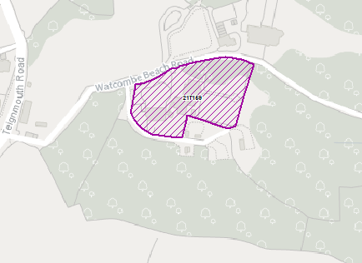
Suitable: How the principle of development is established | The site has planning permission for a conversion to 8 flats and 4 houses – see P/2020/0627
Available: Any change in circumstances since principle established | Builders are currently on site and properties are being marketed.
Achievable
Customer Reference no.
Current use | Vacant at time of application, previously a care home
Site description | The site is a large detached Victorian villa, and lies within the Watcombe Conservation Area. The Local Plan also locates it within Countryside Zone and Undeveloped Coast.
Total site area (ha) | Approximately 0.66ha.

AVAILABILITY ASSESSMENT
Reasonable prospect of delivery (timescale):
Currently on site.
The next 5 years | 12
A 6-10 year period
An 11-15 year period
Later than 15 years

