SITE OVERVIEW - GREEN
Town | Brixham
Site Name | Bishops Court, Lower Warberry Road
HELAA Reference no. | 21T133
Approx. yield | 6
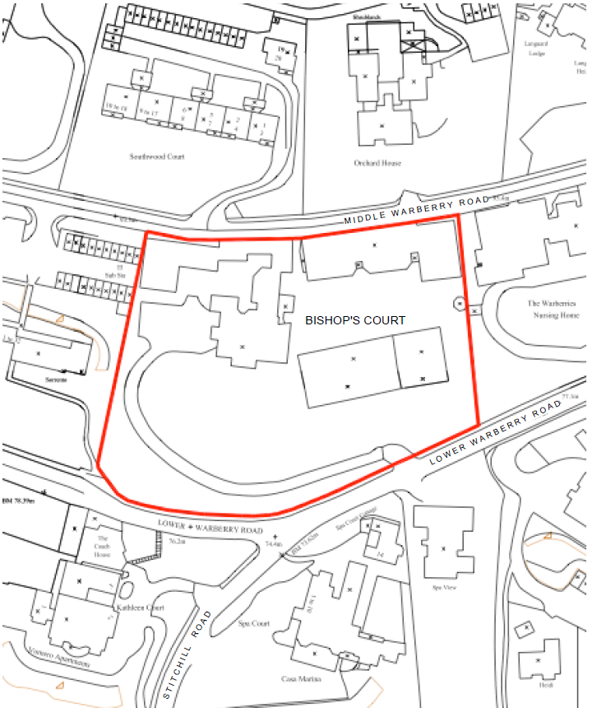
Suitable: How the principle of development is established | The site has planning permission for redevelopment resulting in a net increase of 6 dwellings – see P/2019/1274 which was approved on 9 March 2021.
Available: Any change in circumstances since principle established | Yes, the site remains available. A discharge of conditions application was submitted in August 2021.
Achievable | Yes.
Customer Reference no.
Current use
Site description | The site comprises a complex of buildings associated with a Grade II Listed Victorian Villa and its large curtilage area, set between Lower Warberry Road (which forms the southern site boundary) and Middle Warberry Road (which forms the northern site boundary, located within the Warberries Conservation Area. The buildings are set towards the rear of the site, with ample landscaped grounds including a number of mature trees on the southern part of the site. The plot slopes downhill from the north to the south.
Total site area (ha) | Approximately 0.9ha.

AVAILABILITY ASSESSMENT
Reasonable prospect of delivery (timescale):

The next 5 years | 6
A 6-10 year period
An 11-15 year period
Later than 15 years

