SITE OVERVIEW - GREEN
Town | Torquay
Site Name | Kingsland, Marldon Rd
HELAA Reference no. | 21T125  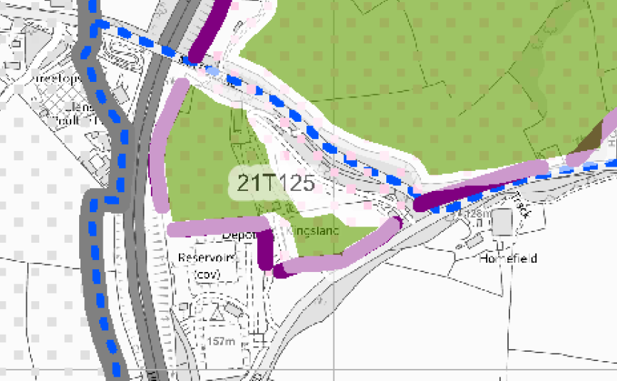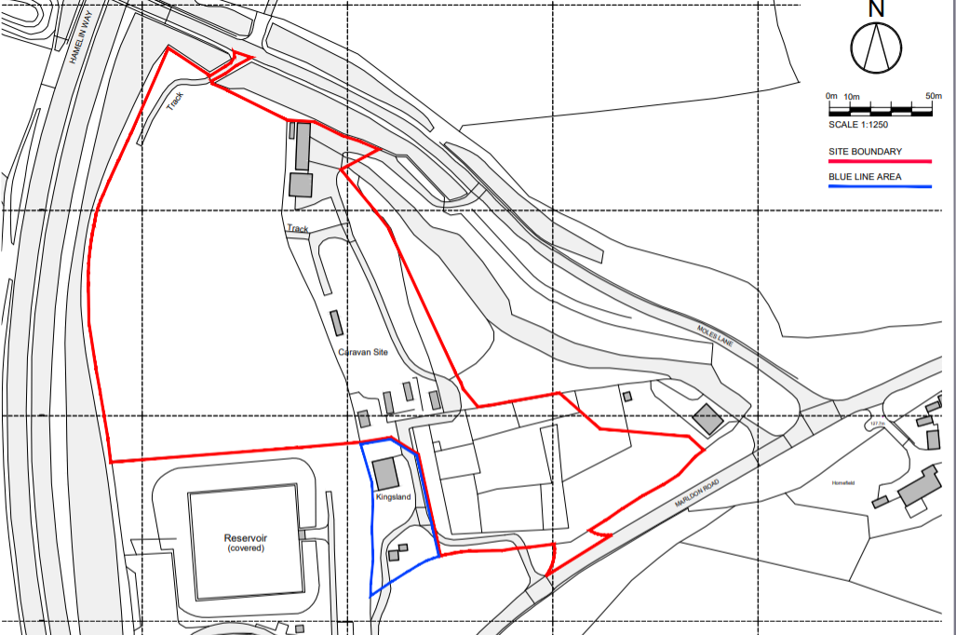
Approx. yield | 0 housing, employment land
Suitable: How the principle of development is established | Not for housing, the site is a plan allocation for employment. (B1 - Offices) Employment (B2 / B8) Light Industrial / Warehouse
Available: Any change in circumstances since principle established | Yes (employment)
Achievable | Yes
Customer Reference no.
Source of Site (call for sites, Local Plan allocation etc.).
Current use | Agriculture/Torbay Grab hire/static homes
Site description | The site relates to an area of land bound by the A380 Hamelin Way to the west, Moles Lane to the north and east and Marldon Road to the south and south-east. A South West Water reservoir is located to the south and west of the site, slightly further south is the Gallows Gate roundabout. The site is accessed off Marldon Road. There is an existing residential dwelling know as ‘Kingsland’ to the south and west of the site.
Total site area (ha) | 3.26ha

AVAILABILITY ASSESSMENT
Reasonable prospect of delivery (timescale):

The next 5 years
A 6-10 year period
An 11-15 year period
Later than 15 years

