SITE OVERVIEW - GREEN
Town | Torquay
Site Name | Land at Hamelin Way and Moles Lane (Edginswell)  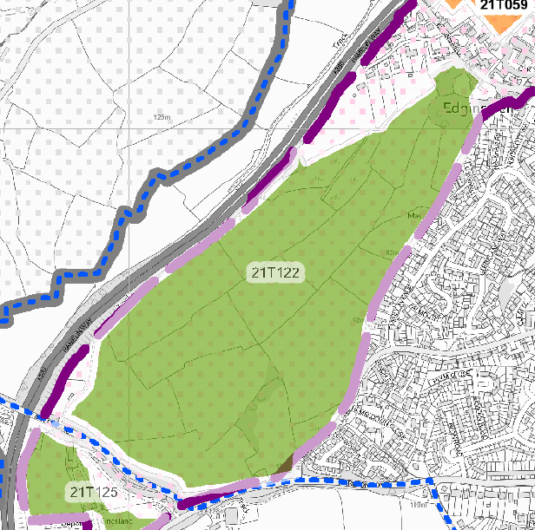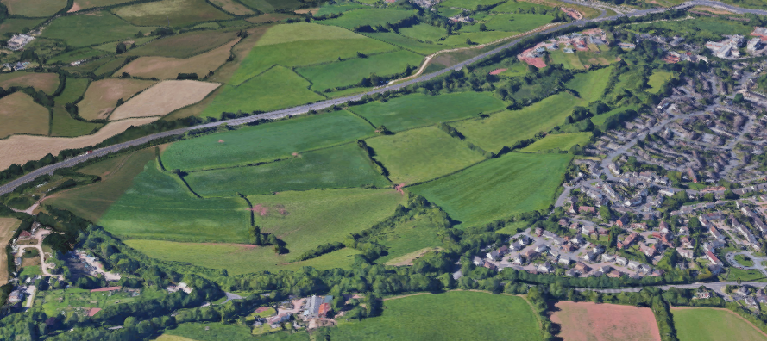  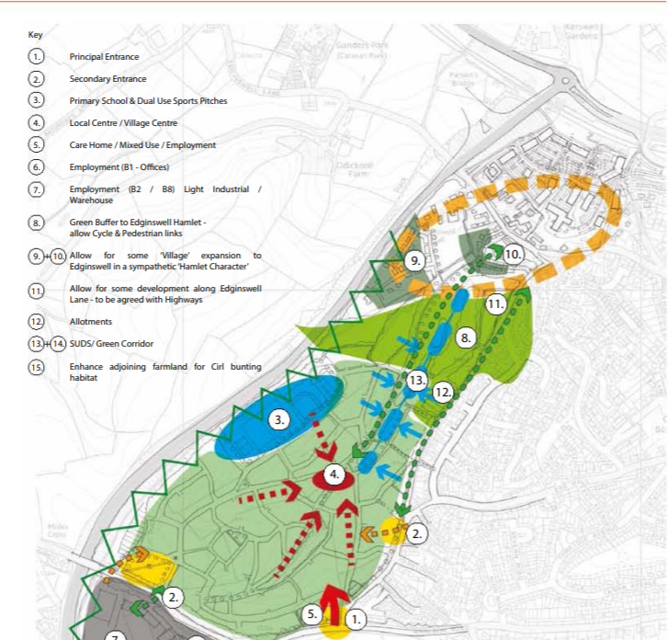  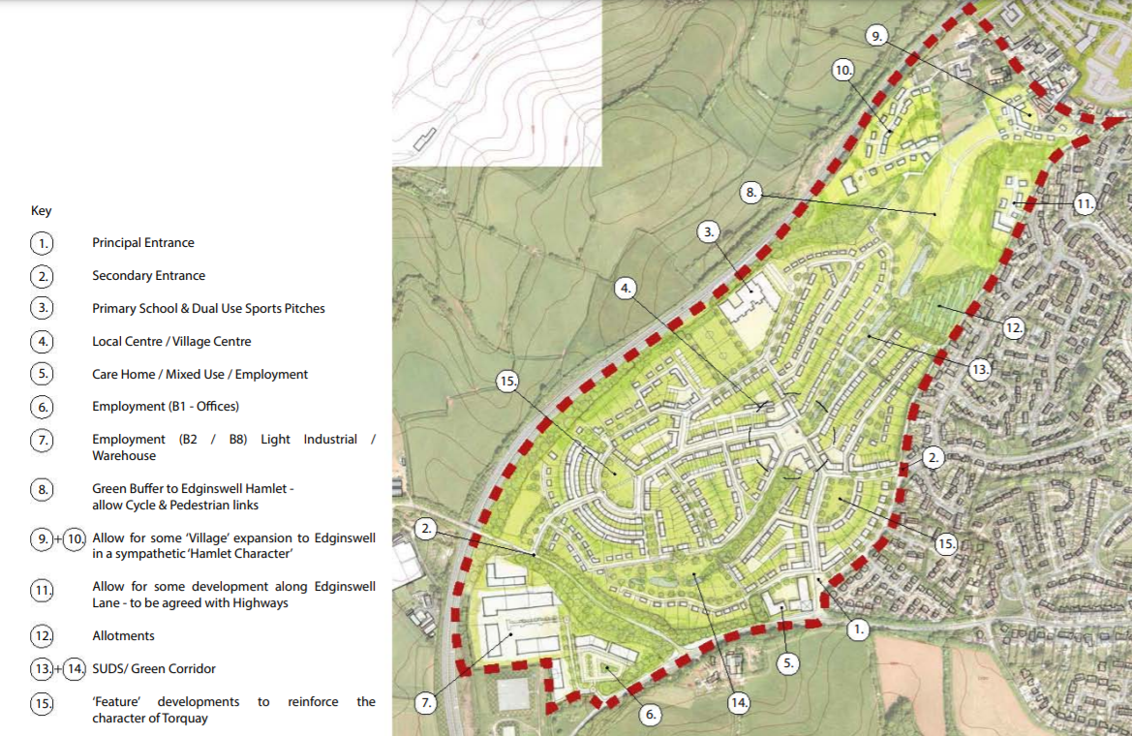
HELAA Reference no. | 21T122
Approx. yield | 400
Suitable: How the principle of development is established | Yes allocated Future Growth Area for housing and related development  in Torquay Gateway (Edginswell) Masterplan  Local Plan Policy SS1 and SS2 – identified as a strategic growth area
Available: Any change in circumstances since principle established | Yes
Achievable | Yes – the steepness of the site effects viability of affordable housing and has led to some delays
Customer Reference no.
Source of Site (call for sites, Local Plan allocation etc.). | Legacy Sites
Current use | Agricultural land
Site description | A number of fields located to the south east of Hamelin Way.
Total site area (ha) | Approx. 33ha

AVAILABILITY ASSESSMENT
Reasonable prospect of delivery (timescale):

The next 5 years
A 6-10 year period | 200
An 11-15 year period | 200
Later than 15 years

