SITE OVERVIEW - GREEN
Town | Torquay
Site Name | Exmouth View Hotel, St Albans Road  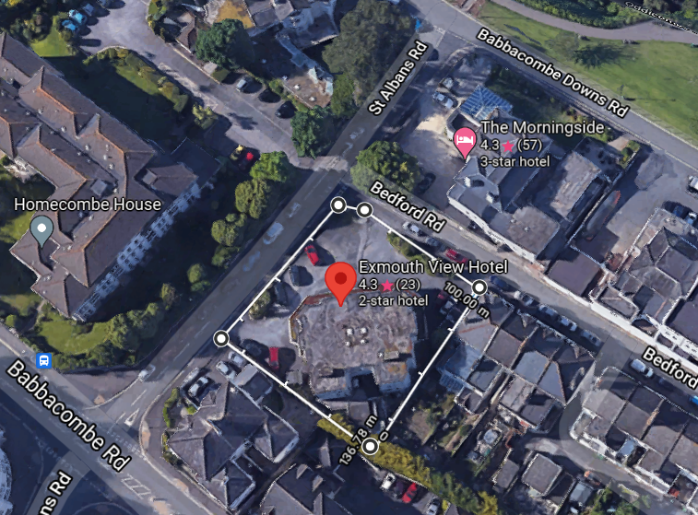
HELAA Reference no. | 21T101
Approx. yield | 12
Suitable: How the principle of development is established | P/2018/1283 – demolition of hotel and construction of 12 apartments and 2 town houses.
Available: Any change in circumstances since principle established | Yes, still available.  Discharge of condition application received in 2020.  Development is under construction.
Achievable | Yes, the site is under construction.
Customer Reference no.
Source of Site (call for sites, Local Plan allocation etc.). | UC Sites
Current use | Former hotel site, recently demolished and currently under construction.
Site description | The site is a corner plot at the junction of St Albans Road and Bedford Road close to Babbacombe Downs in an area with a mixed residential and holiday character. The site is currently being developed pursuant to P/2018/1283.
Total site area (ha) | Approx. 0.1ha

AVAILABILITY ASSESSMENT
Reasonable prospect of delivery (timescale):
The next 5 years | 14
A 6-10 year period
An 11-15 year period
Later than 15 years

