SITE OVERVIEW - GREEN
Town | Torquay
Site Name | 213 St Marychurch Road  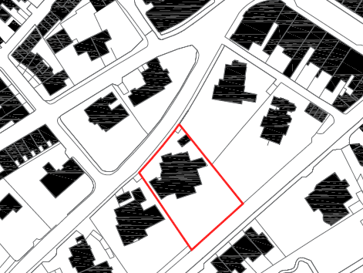  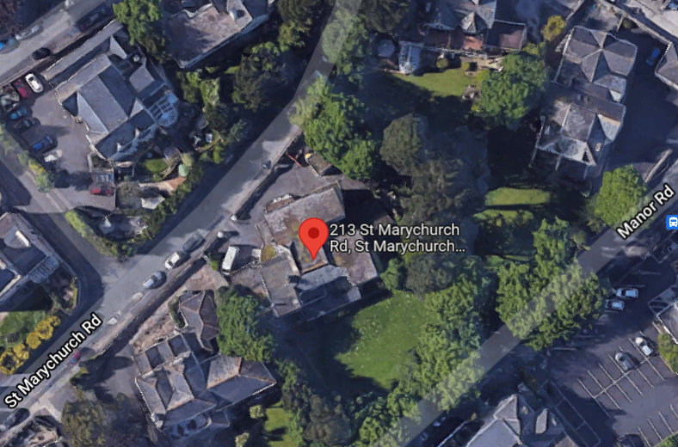
HELAA Reference no. | 21T000
Approx. yield | 17
Suitable: How the principle of development is established | P/2018/0962 – approved - Demolition of existing building to form 17 apartments & parking  Discharge of condition approved September 2021  CIL Liability Notice issued on 13 September 2021.
Available: Any change in circumstances since principle established | Yes.
Achievable | Yes.
Customer Reference no.
Source of Site (call for sites, Local Plan allocation etc.). | UC sites
Current use | Former care home currently being redeveloped for residential.
Site description | The site, 213 St. Marychurch Road, Torquay, previously comprised of a Victorian villa that was in use as a care home. The care home shut down in 2017 and the site is currently being redeveloped for residential use, with a contemporary four-storey building being built on site (pursuant to the approval of P/2018/0962). The site, located within the St. Marychurch Conservation Area, is approximately 0.2ha in area and is screened to its east, south and west elevations by trees. The site lies just outside of the St. Marychurch district centre and within close proximity to a bus stop.
Total site area (ha) | 0.2ha

AVAILABILITY ASSESSMENT
Reasonable prospect of delivery (timescale):

The next 5 years | 17
A 6-10 year period
An 11-15 year period
Later than 15 years

