SITE OVERVIEW - GREEN
Town | Torquay
Site Name | 182 St Marychurch Road  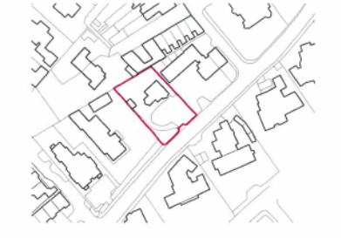  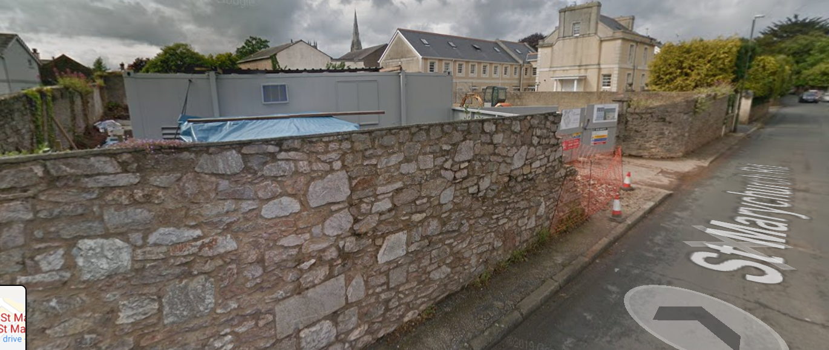
HELAA Reference no. | 21T099
Approx. yield | 8
Suitable: How the principle of development is established | P/2017/1293 - Demolition of existing dwelling and construction of 8 residential units (2 No Town Houses and 6 No Apartments) to include parking and alterations to existing boundary wall.
Available: Any change in circumstances since principle established | Yes.
Achievable | Yes – under construction
Customer Reference no.
Source of Site (call for sites, Local Plan allocation etc.). | UC sites
Current use | Construction site
Site description | The site comprises a detached residential property and its curtilage, located on the northern side of St Marychurch Road. The site is located within the St Marychurch Conservation Area. The site has residential properties to its south west, north west and north east, whilst St Marychurch Road lies to the south east of the site.
Total site area (ha)

AVAILABILITY ASSESSMENT
Reasonable prospect of delivery (timescale):

The next 5 years | 8
A 6-10 year period
An 11-15 year period
Later than 15 years

