SITE OVERVIEW - GREEN
Town | Torquay
Site Name | Rutland Hotel, Daddyhole Road
HELAA Reference no. | 21T097
Approx. yield | 10
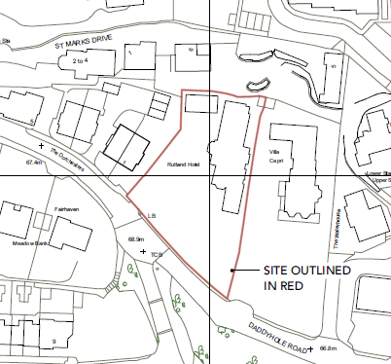
Suitable: How the principle of development is established | P/2017/0751 - Conversion of former Rutland Hotel into 5 flats, partial demolition of existing buildings and construction of 1 no. 3- bed house and 2 no. 4 bed houses  P/2018/0281 - Construction of three storey, four bed house and associated landscaping works  P/2020/0637 | Conversion of existing loft into a 1 bedroom apartment.
Available: Any change in circumstances since principle established | Yes.
Achievable | Yes – under construction
Customer Reference no.
Source of Site (call for sites, Local Plan allocation etc.). | UC sites
Current use | Construction site
Site description | The Former Rutland Hotel, Daddyhole Road, Torquay comprises a Victorian Villa of three storeys, it has a four-storey service wing and a rear interwar two-storey extension with a further floor added in the 1990s. There is a detached two storey annexe to the side. The property stands on a large level site and is well set back from the road frontage to Daddyhole Road. It is positioned in close proximity to its rear boundary from where the land drops steeply away down onto a small development of houses on St Marks Drive to the rear. To the west of the site there is a new development of 5 substantial dwellings "The Dorchesters" which front Daddyhole Road.
Total site area (ha)

AVAILABILITY ASSESSMENT
Reasonable prospect of delivery (timescale):

The next 5 years | 10
A 6-10 year period
An 11-15 year period
Later than 15 years

