SITE OVERVIEW - GREEN
Town | Torquay
Site Name | 18 Babbacombe Road  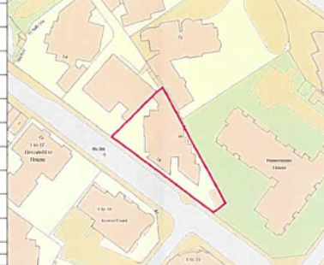  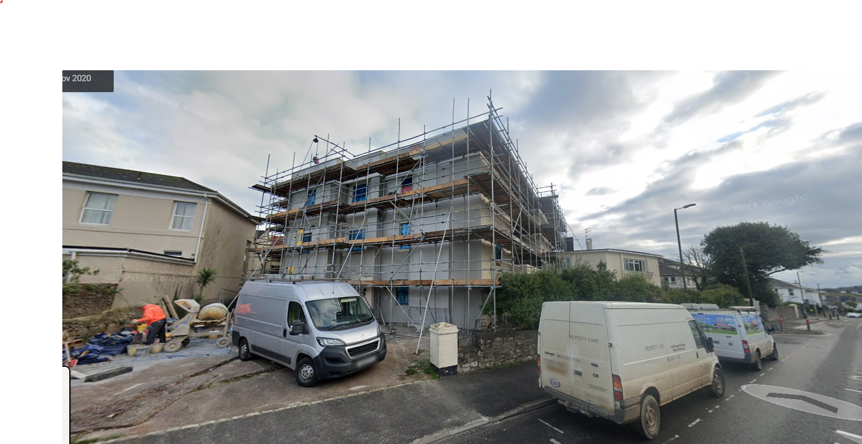
HELAA Reference no. | 21T096
Approx. yield | 10
Suitable: How the principle of development is established | P/2017/0178 - Conversion of Hotel into 9 apartments  P/2017/0729 – Conversion of ancillary space on GF of main building into additional residential unit
Available: Any change in circumstances since principle established | Yes.
Achievable | Yes – under construction
Customer Reference no.
Source of Site (call for sites, Local Plan allocation etc.). | UC sites
Current use | Construction site
Site description | Extended Victorian Villa set adjacent to Babbacombe Road, which is in the process of being altered and convert to flats.
Total site area (ha)

AVAILABILITY ASSESSMENT
Reasonable prospect of delivery (timescale):

The next 5 years | 10
A 6-10 year period
An 11-15 year period
Later than 15 years

