SITE OVERVIEW - GREEN
Town | Torquay
Site Name | Former Stoodley Knowle School, Ansteys Cove Rd
HELAA Reference no. | 21T085
Approx. yield | 90
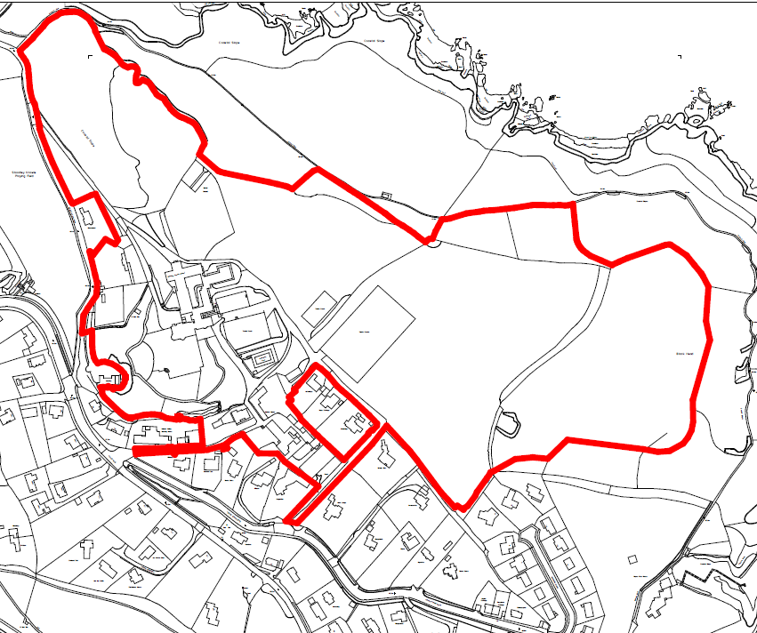
Suitable: How the principle of development is established | P/2019/1330 | Demolition of school site and construction of 90 residential units (houses and apartments), with associated car parking, landscaping and infrastructure. – approved
Available: Any change in circumstances since principle established | Yes
Achievable | Yes
Customer Reference no.
Source of Site (call for sites, Local Plan allocation etc.). | Applications PCO
Current use | Former school and surrounding grounds.
Site description | The site is that of the former Stoodley Knowle School, an independent girls school which closed in 2015, set within the suburb of Wellswood, Torquay, located on an elevated coastal position between Ansteys Cove to the north-west and Hope Cove to the south-east.  The site covers a total of 17.4 hectares and comprises a large complex of buildings along with areas of open meadow, gardens and woodland. The existing buildings are primarily located towards the centre and western parts of the site and are a mixture of styles and ages, varying in scale between larger more modern institutional buildings to much smaller more domestically scaled period buildings. The more domestically  scaled building group towards the southern border of the site includes buildings that are subject to statutory Grade II or II* listings.
Total site area (ha) | 17.4

AVAILABILITY ASSESSMENT
Reasonable prospect of delivery (timescale):

The next 5 years | 90
A 6-10 year period
An 11-15 year period
Later than 15 years

