SITE OVERVIEW - GREEN
Town | Torquay
Site Name | Former Bakery Barn, Chilcote Close, St Marychurch
HELAA Reference no. | 21T082
Approx. yield | 9
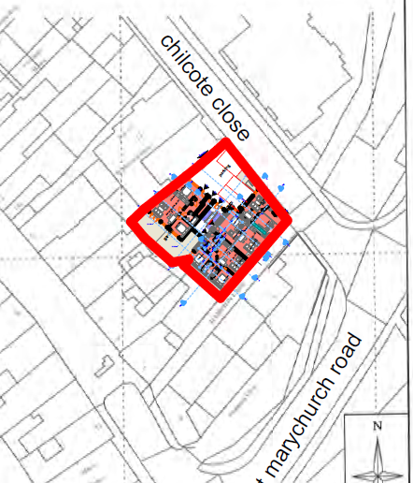
Suitable: How the principle of development is established | P/2018/1132  P/2019/0141 | Conversion and extension of existing stone barn to form nine residential apartments
Available: Any change in circumstances since principle established | Yes
Achievable | Yes
Customer Reference no.
Source of Site (call for sites, Local Plan allocation etc.). | Applications PCO
Current use | Construction site for approved development
Site description | The application site comprises a former bakery on the corner of Chilcote Close within the St. Marychurch Conservation Area.
Total site area (ha)

AVAILABILITY ASSESSMENT
Reasonable prospect of delivery (timescale):

The next 5 years | 9
A 6-10 year period
An 11-15 year period
Later than 15 years

