SITE OVERVIEW - GREEN
Town | Torquay
Site Name | La Rosaire, Livermead Hill
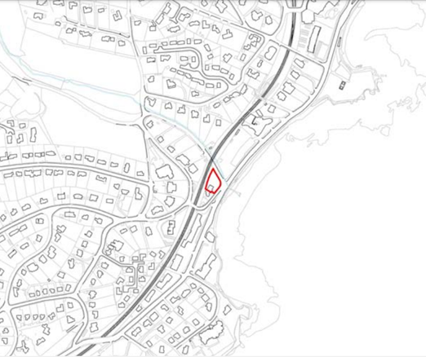
Allocation or HELAA Reference no. | 21T051  SHLAA/Housing Land Monitor Reference: 13024  Planning Application Reference: P/2014/1182 (demolition and construction of 8 flats), P/2018/0683 (variation), P/2020/1254 (addition of 1 additional flat to consented scheme)  21T051
Approx. yield | 8 (9 minus the 1 previously existing unit)
Suitable: How the principle of development is established | The site was allocated in the Torquay Neighbourhood Plan (TNPH44) for 7 units based on an implemented (but not yet completed) permission for redevelopment of the site. Since allocation, the site has been the subject of a further permission which added 1 additional unit to the consented scheme.
Available: Any change in circumstances since principle established | Given that redevelopment of the site is ongoing with the most recent planning permission dating from 2020 (as well as a live discharge of conditions application), the site is available.
Achievable | Yes. The approved development is under construction.
Customer Reference no.
Current use | Under construction.
Site description | The site previously hosted a semi-detached building comprising a hotel which has since been demolished. Redevelopment of the site is ongoing.
Total site area (ha) | Approximately 0.11ha.

AVAILABILITY ASSESSMENT
Reasonable prospect of delivery (timescale):

The next 5 years | 8
A 6-10 year period
An 11-15 year period
Later than 15 years

