SITE OVERVIEW - GREEN
Town | Torquay
Site Name | Roebuck House, Abbey Road, Torquay
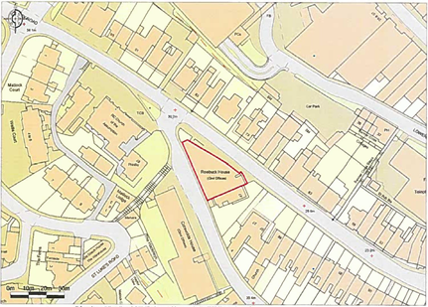
Allocation or HELAA Reference no. | Map Site Label: TNPH30  Neighbourhood Plan Reference: TNPH27  SHLAA/Housing Land Monitor Reference: 13003  Planning Application References: P/2021/0733, P/2018/0468, P/2016/0531, P/2014/0325.
Approx. yield | 49
Suitable: How the principle of development is established | Yes – site is allocated in the Neighbourhood Plan. Prior approval for change of use from offices to 49 residential flats (P/2021/0733) granted on 16 August 2021.
Available: Any change in circumstances since principle established | Yes – very recent permission. Prior to that, the site was also the subject of an appeal decision (reference APP/X1165/L/19/1200351, relating to CIL) which was issued on 8 December 2020. (The appeal decision concluded that, notwithstanding that certain works had been carried out on site, the development approved in terms of P/2018/0468 had not commenced.)
Achievable | Yes
Customer Reference no.
Current use | Vacant, formerly offices.
Site description | Seven storey building within Torquay’s town centre on a triangular shaped plot at the corner of Abbey Road and Warren Road.
Total site area (ha) | Approximately 0.065

AVAILABILITY ASSESSMENT
Reasonable prospect of delivery (timescale):

The next 5 years | 49
A 6-10 year period
An 11-15 year period
Later than 15 years

