SITE OVERVIEW - GREEN
Town | Torquay
Site Name | Zion Methodist Church, Zion Road
Allocation or HELAA Reference no. | 21T031
Approx. yield | 8 according to Torquay Neighbourhood Plan allocation.  6 according to approval P/2016/0914.
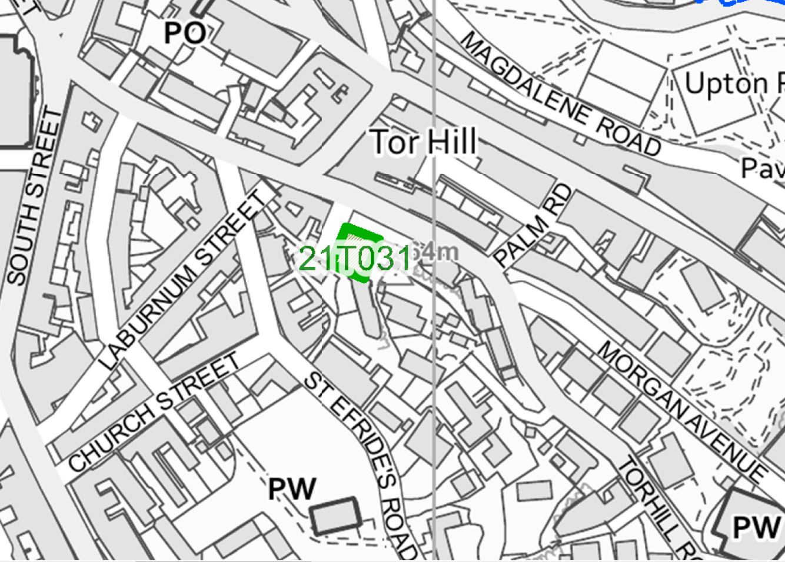
Suitable: How the principle of development is established | Yes - Allocated in the Torquay Neighbourhood Plan (TNPH18) for 8 units.
Available: Any change in circumstances since principle established | P/2016/0914 6 apartments approved – material start of works in 2019  Advertised for sale in Nov 2020
Achievable | Achievable subject to availability.
Customer Reference no.
Current use | Vacant former chapel/garage?
Site description | The site is a traditional stone built chapel building which faces Zion Place.
Total site area (ha) | 0.06

AVAILABILITY ASSESSMENT
Reasonable prospect of delivery (timescale):

Confirmation of availability needed from owners.
The next 5 years | 8
A 6-10 year period
An 11-15 year period
Later than 15 years

