SITE OVERVIEW - GREEN
Town | Torquay
Site Name | Torre House, Falkland Road
HELAA Reference no. | 21T011
Approx. yield | 8
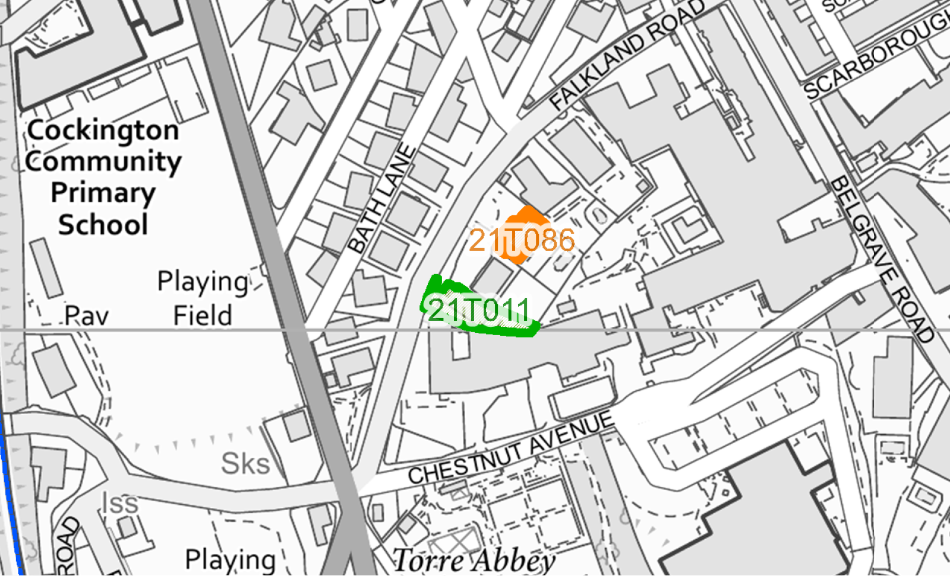
Suitable: How the principle of development is established | The site has planning permission for conversion from a residential institution (care home) to 8 apartments – see planning permissions P/2019/1188 and P/2016/1356.
Available: Any change in circumstances since principle established | Given thatP/2019/1188 was submitted on 6 November 2019 and approved on 10 June 2020, it would appear that the site remains available, although it is noted that the conditions are yet to be discharged.
Achievable
Customer Reference no.
Current use | Care home/Student residence (EF)/Vacant?
Site description | The site, Torre House, comprises a large triple-storey (with a small basement level) Victoria villa and its curtilage, in a fairly prominent position above Falkland Road (which forms the western boundary) along which there is a stone retaining wall. The site, which is located within Belgravia Conservation Area, is one of a group of three large Victorian buildings that take access via a shared private drive and parking area off Falkland Road.
Total site area (ha) | Approximately 0.09ha.

AVAILABILITY ASSESSMENT
Reasonable prospect of delivery (timescale):

The next 5 years | 8
A 6-10 year period
An 11-15 year period
Later than 15 years

