SITE OVERVIEW - GREEN
Town | Torquay
Site Name | Wolverton and Mowbray, Asheldon Road
HELAA Reference no. | 21T007
Approx. yield | 6
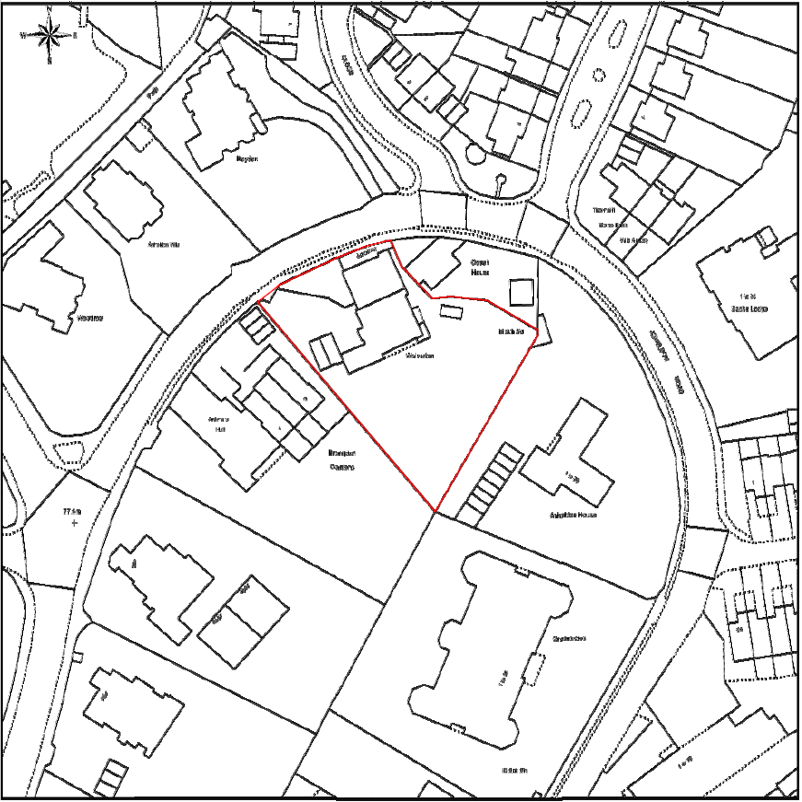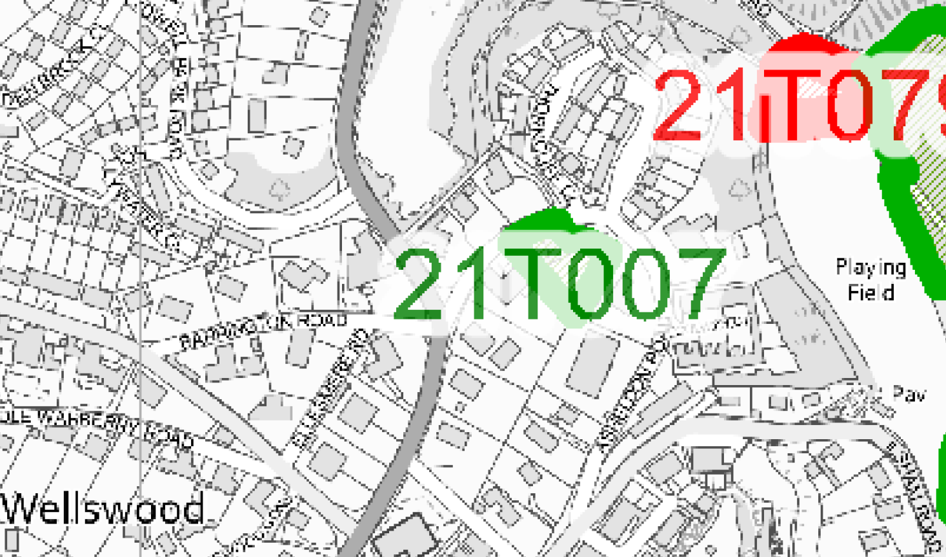
Suitable: How the principle of development is established | The site has planning permission for conversion of the existing villa (which comprises 2 dwellings) into 7 apartments and 1 dwelling house (giving rise to a net increase of 6 units) - see P/2019/0323.
Available: Any change in circumstances since principle established | Given that the permission was granted on 17 October 2019, it would appear that the site remains available, although it is noted that the conditions are yet to be discharged.
Achievable
Customer Reference no.
Current use | Residential.
Site description | The site is the plot of a large detached Victorian Villa that currently holds two dwellings within it, which is set off Asheldon Road in Torquay within the Lincombes Conservation Area. The Villa sits towards the front of the plot near to the adjacent highway with a large tree-lined garden to the rear. There are two vehicular access points, the main Villa (Wolverton) has a gravelled drive that runs along the side of the building adjacent to the principal elevation of the building. The dwelling in the former service wing (Mowbray) has a visually prominent flat-roofed garage and hardstand close to the adjacent highway where 5-6 metres of the front stone boundary wall has been removed.
Total site area (ha) | Approximately 0.2285ha.

AVAILABILITY ASSESSMENT
Reasonable prospect of delivery (timescale):

The next 5 years | 6
A 6-10 year period
An 11-15 year period
Later than 15 years

