SITE OVERVIEW - GREEN
Town | Torquay
Site Name | Former Palace Hotel, Babbacombe Road
HELAA Reference no. | 21T006
Approx. yield | 38
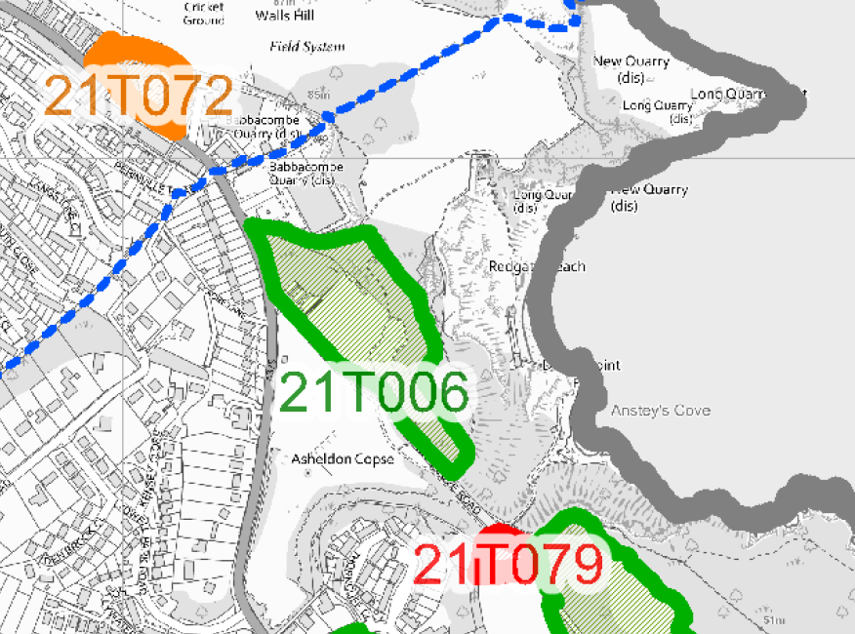
Suitable: How the principle of development is established | The site has planning permission for 38 dwellinghouses – see P/2019/0716, as varied by P/2021/0181.
Available: Any change in circumstances since principle established | Yes, the site is still available. Demolition and groundworks are being carried out pursuant to the granting of P/2019/0716 and P/2021/0181 (which was submitted on 13 February 2021 and approved on 1 October 2021).
Achievable | Yes.
Customer Reference no.
Current use | Vacant/building site. THe site is being redeveloped for residential use.
Site description | The site comprises part of the grounds of the Former Palace Hotel on the northeastern side of Ansteys Cove Road which forms the southwestern boundary. The site previously hosted an ancillary building and tennis courts associated with the former hotel which have been demolished. The northeastern, northwestern, and southeastern edges of the site comprise of woodland.
Total site area (ha) | Approximately 3ha.

AVAILABILITY ASSESSMENT
Reasonable prospect of delivery (timescale):

The next 5 years | 38
A 6-10 year period
An 11-15 year period
Later than 15 years

