SITE OVERVIEW - GREEN
Town | Torquay
Site Name | 3-5 Union Street
HELAA Reference no. | 21T005
Approx. yield | 8
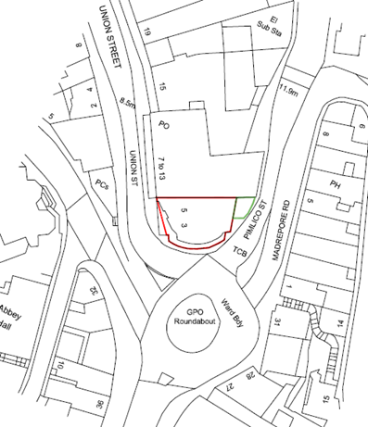
Suitable: How the principle of development is established | The site has planning permission for 8 dwellings apartments on the first, second and third floors above the ground floor commercial unit – see P/2019/1208.
Available: Any change in circumstances since principle established | Given that the permission was granted on 3 February 2020 it would appear that the site remains available, although it is noted that the conditions are yet to be discharged.
Achievable
Customer Reference no.
Current use | Restaurant/café on the ground floor, vacant on the floors above.
Site description | The site comprises a four-storey property in a prominent location in Torquay’s town centre on the northern side of the roundabout at the junction of Union Street, Pimlico, Madrepore Road, Fleet Street and Abbey Road. The property, which forms part of the Primary Shopping Frontage in terms of the Local Plan, comprises a Costa on the ground floor with vacant space within the floors above.
Total site area (ha) | Approximately 0.026ha.

AVAILABILITY ASSESSMENT
Reasonable prospect of delivery (timescale):

The next 5 years | 8
A 6-10 year period
An 11-15 year period
Later than 15 years

