SITE OVERVIEW - GREEN
Town | Torquay
Site Name | 21 Old Mill Road
HELAA Reference no. | 21T004
Approx. yield | 11
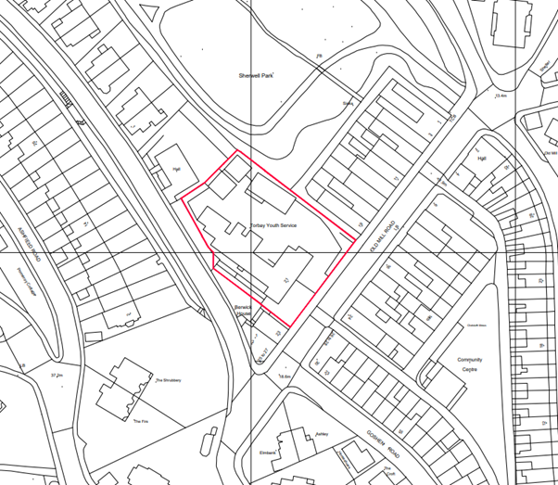
Suitable: How the principle of development is established | The site has planning permission for 11 dwellings (4 houses and 7 apartments) – see P/2019/0919, as varied by P/2021/0550.
Available: Any change in circumstances since principle established | Yes, the site is still available. A Section 73 application to vary the permission (P/2021/0550) was submitted on 7 May 2021 and approved on 7 October 2021.
Achievable | Yes.
Customer Reference no.
Current use | Former school site, in the process of being redeveloped for residential.
Site description | The site is occupied by a 19th Century former school building, three temporary classrooms and associated car parking. There is an existing vehicular access to the site from Old Mill Road. The site area is 2,258 square metres in area and lies on the north-western side of Old Mill Road. The site is adjacent to, but not within, the Chelston Conservation Area. To the northwest of the site is a Christadelphian Hall and to the north is Sherwell Park. To the northeast of the site is a service lane that divides the site from the local amenities of Old Mill Road, Chelston Local Centre and residential accommodation. Similarly, to the southeast of the site, is Old Mill Road which divides the site from local amenities and residential accommodation.
Total site area (ha) | Approximately 0.22ha.

AVAILABILITY ASSESSMENT
Reasonable prospect of delivery (timescale):

The next 5 years | 11
A 6-10 year period
An 11-15 year period
Later than 15 years

