SITE OVERVIEW - GREEN
Town | Torquay
Site Name | Shelley Court Hotel, 29 Croft Road
HELAA Reference no. | 21T003
Approx. yield | 11
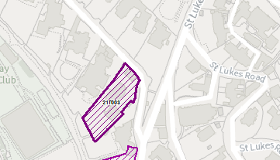
Suitable: How the principle of development is established | The site has planning permission for a change of use, extension and alterations to 10 one and two bedroom apartments and 1 house – see P/2019/0337
Available: Any change in circumstances since principle established | Given that the permission was granted on 20 October 2021 it would appear that the site is available.
Achievable
Customer Reference no.
Current use | Hotel
Site description | The site is a two-storey detached Victorian villa, noted as a key building within the Belgravia Conservation Area. The Local Plan also locates it within a Community Investment Area.
Total site area (ha) | Approximately 0.2ha.

AVAILABILITY ASSESSMENT
Reasonable prospect of delivery (timescale):
Currently on site.
The next 5 years | 11
A 6-10 year period
An 11-15 year period
Later than 15 years

