SITE OVERVIEW - GREEN
Town | Torquay
Site Name | Former Dairy Crest Depot, Parkfield Road
HELAA Reference no. | 21T002
Approx. yield | 55
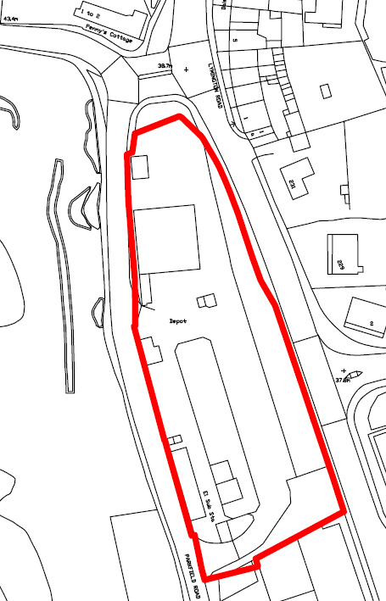
Suitable: How the principle of development is established | The site has outline consent (P/2019/0283) for demolition and construction of 43 dwellings, granted on 28.10.2019. The site is also subject to a live application for 55 dwellings which, while still pending decision (I.e. the decision letter has not yet been issued), has been approved at Planning Committee.  The site is allocated in the Torquay Neighbourhood Plan – NP3, 40 units.
Available: Any change in circumstances since principle established | Yes, still available.
Achievable | Yes.
Customer Reference no.
Source of Site (call for sites, Local Plan allocation etc.). | NS Sites
Current use | Former Dairycrest milk depot, currently vacant.
Site description | Vacant former Dairycrest milk depot site comprising warehousing and hardstanding located between Lymington Road (which forms the eastern boundary), Penny’s Hill (which forms the northern boundary), and Parkfield Road (which forms the western boundary.
Total site area (ha) | Approx. 0.45ha

AVAILABILITY ASSESSMENT
Reasonable prospect of delivery (timescale):

The next 5 years | 55
A 6-10 year period
An 11-15 year period
Later than 15 years

