SITE OVERVIEW - GREEN
Town | Torquay
Site Name | Electricity Substation Adjacent Charlwood Court, Chilcote
HELAA Reference no. | 21T001
Approx. yield | 6
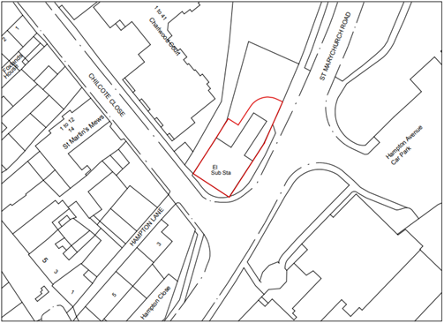
Suitable: How the principle of development is established | Development comprising 6 apartments currently under construction pursuant to planning permission P/2019/0966 which was approved on 29.01.2020. CIL Liability Notice issued on 21 September 2021.
Available: Any change in circumstances since principle established | Yes, under construction.
Achievable | Yes, under construction.
Customer Reference no.
Source of Site (call for sites, Local Plan allocation etc.). | NS Sites
Current use | Residential, under construction. (Formerly an electricity substation.)
Site description | Building site located on the corner of Chilcote Close and St Marychurch Road opposite the entrance to Hampton Avenue Car Park. Development comprising 6 apartments currently under construction.
Total site area (ha) | 0.0326ha

AVAILABILITY ASSESSMENT
Reasonable prospect of delivery (timescale):

The next 5 years | 6
A 6-10 year period
An 11-15 year period
Later than 15 years

