SITE OVERVIEW : Amber sites – significant constraints
Town | Torquay
Site Name | Land at Sladnor Park Road
HELAA Reference no. | 21T144
Approx. yield | 8
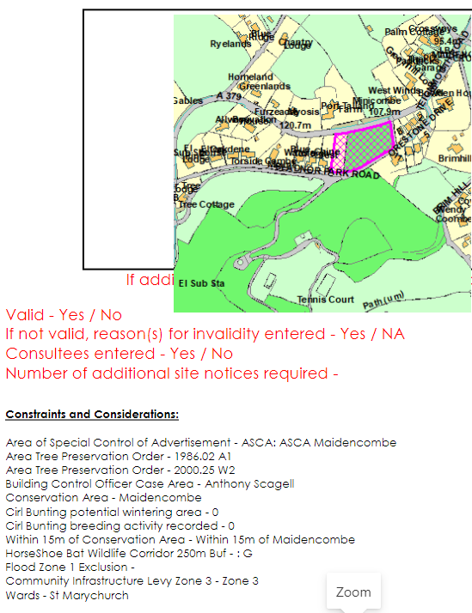
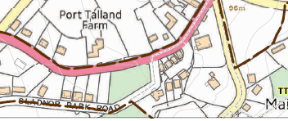
Suitable | Yes
Available | Need confirmation, but the land has recently been available for sale
Achievable | Yes - would be attractive to housebuilders
Customer Reference no.
Source of Site (call for sites, Local Plan allocation etc.). | Post Panel Addition
Current use | Scrubby woodland
Site descriptions | An area of scrubby woodland and an adjoining field/garden located between Sladnor Park Road and Teignmouth Road.
Total site area (ha) | Approx. 0.5
Gross site area (ha) | Approx. 0.4

SUITABILITY ASSESSMENT: STAGE A

Strategic potential: | No
Housing? | Yes
Employment? | No
Other Use? | No
Biodiversity- Within SAC/SSSI | Within south hams SAC GHB Landscape Connectivity Zone
Flood Zone 3b | No
Other NPPF Showstoppers (not policy constraints) | None

SUITABILITY ASSESSMENT: STAGE B

Access | Via Sladnor Park Road or Teignmouth Road
Flood risk, water quality and drainage | N/A
Heritage and Archaeology (including distance from assets). | May require programme of archaeological mitigation.  15m from the Maidencombe Conservation Area.
Infrastructure | Drainage/ sewerage infrastructure needed
Landscape | Site is within the Undeveloped Coast Undeveloped Coast Policy C2: Maidencombe To Daddyhole  All or part of the site appears to be in the Landscape Character Area: 1A Rolling Farmland – Highly sensitive, Management Strategy – Conserve and enhance
Ecology | Part of the site is within a Cirl Bunting breeding territory.  Site within Greater Crested Newts consultation zone.  Scrubby woodland is of high ecological value so any development would require mitigation/compensation
Safety related constraints | No
Soils (Agricultural Land classification) and contamination | Poor (grade 4)
Local Plan | Trees, hedgerows and natural landscape features (Policy C4)  Biodiversity and Geodiversity (Policy NC1)  SS8 – Natural Environment  C2 – Undeveloped Coast
Neighborhood Plan | Green Corridors (Policy TE4)  Inside Maidencombe village envelope (TNP) policy TH12
Development progress (where relevant) | No
Other
HELAA Panel Summary
Site potential | Confirmation of availability needed.

AVAILABILITY ASSESSMENT
Reasonable prospect of delivery (timescale):

The next 5 years
A 6-10 year period | 8
An 11-15 year period
Later than 15 years

