SITE OVERVIEW: Amber sites – significant constraints
Town | Torquay
Site Name | Land south of Longpark Hill, Maidencombe
HELAA Reference no. | 21T143
Approx. yield | 20
Suitable | See below
Available | Not clear
Achievable | Uplift in land value would be likely to render development viable.
Customer Reference no.
Source of Site (call for sites, Local Plan allocation etc.). | Post Panel site addition.
Current use | Agriculture
Site descriptions | Land between Ridge Road, Longpark Hill, Stoke Road and Teignmouth Road, Maidencombe
Total site area (ha)
Gross site area (ha) | 2.5
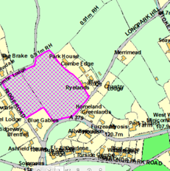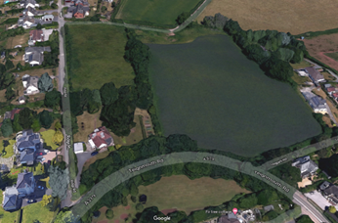

SUITABILITY ASSESSMENT: STAGE A

Strategic potential: | Only in conjunction with nearby sites.
Housing? | Circa 20
Employment? | No -landscape impact
Other Use? | No
Biodiversity- Within SAC/SSSI | Agricultural land:
Flood Zone 3b | No
Other NPPF Showstoppers (not policy constraints) | No
Conclusion | Distance from services and landscape impact are likely to be constraints.

SUITABILITY ASSESSMENT: STAGE B

Access | From A379 Teignmouth Road, wither directly or via Long Park Hill or Ridge Road.
Flood risk, water quality and drainage | No
Heritage and Archaeology (including distance from assets). | Would need detailed assessment – but not thought to be significant.
Infrastructure | Distance from the built up area. Development would be car dependent despite bus service (no 22) between Torquay and Teignmouth . No mains sewers.
Landscape | Countryside Area. AOLC 1A Rolling Farmland 1A Barton. Highly sensitive- conserve and enhance.
Ecology | Cirl Buntings and Greater Horsehoe bat Sustenance Zone.
Safety related constraints | No
Soils (Agricultural Land classification) and contamination | Agricultural land
Local Plan | C1 Countryside Area
Neighbourhood Plan | Outside maidencombe Village ernvelope- contrary to Policy TH12
Development progress (where relevant) | No
Other | Close to boundary with Teignbridge. Impact on wider rural valley system (AGLV in Teignbridge).
HELAA Panel Summary | Added post panel.
Site potential | Inserted following suggestion of panel

AVAILABILITY ASSESSMENT
Site has significant constraints. It is distant from main settlements and largely car dependent. There are no mains sewers, and there would be at least some landscape impact on the wider Rocombe Valley. Likely to only be acceptable as part of a wider Maidencombe broad location.

The next 5 years | Yield 6 (HELAA total spreadsheet)
A 6-10 year period
An 11-15 year period | 20
Later than 15 years

