SITE OVERVIEW : Amber sites – significant constraints
Town | Torquay
Site Name | Land South of Gabwell Hill, Maidencombe
HELAA Reference no. | 21T142
Approx. yield | 30
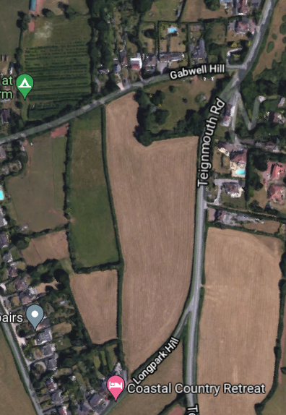

Suitable | Torbay Local Plan- Countryside Area (C1)  Landscape Character Assessment 1A Rolling Farmland – Highly sensitive  Part of wider County Wildlife Site.  Outside of Maidencombe village envelope (TNP) policy TH12  Within Cirl bunting breeding territory
Available | Need confirmation?
Achievable | Would be attractive to housebuilders
Customer Reference no.
Source of Site (call for sites, Local Plan allocation etc.). | Post Panel Addition
Current use | Agricultural Land
Site descriptions | The site is two agricultural fields which are bordered by Teignmouth Road to the east and Gabwell Hill to the north.
Total site area (ha) | Approx. 3ha
Gross site area (ha) | Approx. 1.8ha

SUITABILITY ASSESSMENT: STAGE A

Strategic potential: | No
Housing? | Yes
Employment? | No
Other Use? | No
Biodiversity- Within SAC/SSSI | Within south hams SAC GHB Landscape Connectivity Zone
Flood Zone 3b | No
Other NPPF Showstoppers (not policy constraints) | None

SUITABILITY ASSESSMENT: STAGE B

Access | Teignmouth Road or Gabwell Hill
Flood risk, water quality and drainage | No
Heritage and Archaeology (including distance from assets). | Likely requires programme of archaeological mitigation.
Infrastructure | Drainage/ sewerage infrastructure needed
Landscape | Torbay Local Plan- Countryside Area (C1)  Landscape Character Assessment 1A Rolling Farmland – Highly sensitive  Development likely to have some impacts on landscape.
Ecology | The entire site is located within Cirl Bunting breeding territory  Site within Greater Crested Newts consultation zone.  Site is within Maidencombe And Lower Gabwell Fields LNR
Safety related constraints | No
Soils (Agricultural Land classification) and contamination | Very good.
Local Plan | Urban Landscape Protection Area (Policy C5)  Trees, hedgerows and natural landscape features (Policy C4)  Biodiversity and Geodiversity (Policy NC1)  SS8 – Natural Environment  C1 – Countryside area
Neighbourhood Plan | Green Corridors (Policy TE4)  TH12 Maidencombe- the site is outside of the Village Envelope.
Development progress (where relevant) | No
Other
HELAA Panel Summary
Site potential | Confirmation of availability needed from owners, if considered suitable. But may be considered unsuitable due to landscape impact and relative remoteness.

AVAILABILITY ASSESSMENT
Reasonable prospect of delivery (timescale):

The next 5 years
A 6-10 year period
An 11-15 year period | 30
Later than 15 years

