SITE OVERVIEW : Amber sites – significant constraints
Town | Torquay
Site Name | Former New Look, Union Street
HELAA Reference no. | 21T141
Approx. yield | 20
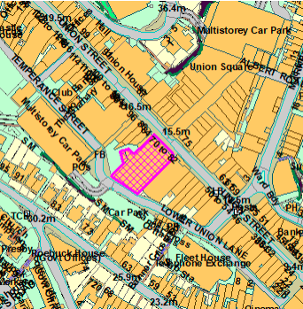
Suitable | Yes, highly sustainable town centre brownfield site that is suitable as a mixed use development with residential development on upper floors and ground floor commercial units. The ground floor units could potentially be suitable for conversion to residential subject to a more comprehensive retail study and review of town centre designations. Suitability is subject to the findings of an updated Strategic Flood Risk Assessment.
Available | The unit is large, over numerous floors and currently vacant.
Achievable | Apartments in town centre areas (without sea views and outside of desirable areas such as Conservation Areas) are reported by the development industry to have limited viability in the current market. The site is therefore only likely to be achievable in the longer term should viability improve and/or a programme of town centre regeneration be implemented.
Customer Reference no.
Source of Site (call for sites, Local Plan allocation etc.). | Post Panel Addition
Current use | Currently vacant, formerly occupied by the clothes retailer New Look until its closure in April 2019.
Site descriptions | Large 2/3 storey unit with warehouse-type access and a few parking spaces to the rear. Fronting Union Street and with rear access via Lower Union Lane.
Total site area (ha) | Approx. 0.15ha
Gross site area (ha)

SUITABILITY ASSESSMENT: STAGE A

Strategic potential: | No
Housing? | Yes
Employment? | Yes – could be used for offices.
Other Use? | Social housing, older persons’ housing.
Biodiversity- Within SAC/SSSI | No
Flood Zone 3b | Flood Zone 3
Other NPPF Showstoppers (not policy constraints) | None

SUITABILITY ASSESSMENT: STAGE B

Access | Existing site access via Union Street and Lower Union Lane. Good access to public transport, and walking and cycling infrastructure.
Flood risk, water quality and drainage | The site is located within Flood Zone 3 in terms of the Environment Agency flood map, and within a Flood Risk Area in terms of the Torbay Local Plan. Subject to Strategic Flood Risk Assessment.
Heritage and Archaeology (including distance from assets). | No significant heritage constraints.
Infrastructure | Town centre site with existing infrastructure connections.
Landscape | No significant constraints.
Ecology | The site is located within the Greater Crested Newt Consultation Zone, however it is a brownfield site and therefore this is unlikely to be relevant. Conversion/redevelopment of redundant space would need to be subject to a Bat and Breeding Bird Survey.
Safety related constraints | Any scheme should be designed to reduce the potential for crime.
Soils (Agricultural Land classification) and contamination | N/A
Local Plan | Community Investment Area (Policy SS11)  Flood Risk (Policy ER1)  If applicable, conversion of ground floor retail units would need to be considered in terms of Policies TC1 (Town Centre), TC2 (Torbay retail hierarchy) and TC4 (Change of retail use).
Neighbourhood Plan | Policy TS2 Masterplans, TS3 Community led planning, TS4 Support for brownfield and greenfield development, TH5 Sustainable later life homes
Development progress (where relevant) | N/A
Other
HELAA Panel Summary
Site potential

AVAILABILITY ASSESSMENT
Reasonable prospect of delivery (timescale):
The next 5 years
A 6-10 year period
An 11-15 year period | 20
Later than 15 years

