SITE OVERVIEW : Amber sites – significant constraints
Town | Torquay
Site Name | Castle Circus House and adjacent buildings, Union Street
HELAA Reference no. | 21T140
Approx. yield | 30
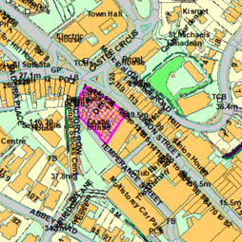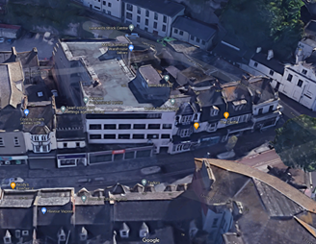
Suitable | Yes, highly sustainable town centre brownfield site that is suitable for residential-led redevelopment. Suitability is subject to the findings of an updated Strategic Flood Risk Assessment, and subject to a design that conserves and enhances the setting of nearby Conservation Areas and listed buildings. Potentially there would be a need to retain a ground floor retail/commercial frontage onto Union Street, however this is subject to a more comprehensive retail study and review of town centre area designations.
Available | The block includes ground floor retail/commercial uses fronting onto Union Street as well as a four storey office building (Castle Circus House), much of which is in commercial use and is therefore not currently available. Some of the floors above the ground floor retail/commercial units and the buildings to the rear appear to be underutilized and may be available.
Achievable | The site would only be achievable in the long term (longer than 15 years) due to the complexities surrounding land ownership and assembly, and due to the limited viability for apartments in town centre areas (without sea views and outside of desirable areas such as Conservation Areas) in the current market, as reported by the development industry.
Customer Reference no.
Source of Site (call for sites, Local Plan allocation etc.). | Post Panel Addition
Current use | The ground floor units fronting onto Union Street comprise of retail, offices, an estate agent, a restaurant/takeaway, a gym, and a pub. The four storey Castle Circus House comprises of offices. The floors above and the buildings to the rear are either in residential use, vacant, or used for storage.
Site descriptions | A block of buildings in Torquay’s town centre, located between Union Street, Factory Row, and Temperance Street. The northeastern elevations form part of the retail frontage onto Union Street.
Total site area (ha) | Approx. 0.19ha
Gross site area (ha)

SUITABILITY ASSESSMENT: STAGE A

Strategic potential: | No
Housing? | Yes
Employment? | Yes – the block could continue to be used for town centre commercial uses.
Other Use? | Social housing, older persons’ housing.
Biodiversity- Within SAC/SSSI | No
Flood Zone 3b | Flood Zone 3
Other NPPF Showstoppers (not policy constraints) | None

SUITABILITY ASSESSMENT: STAGE B

Access | Existing site access via Union Street, Factory Row, and Temperance Street. Good access to public transport, and walking and cycling infrastructure.
Flood risk, water quality and drainage | Parts of the site are located within Flood Zone 3 in terms of the Environment Agency flood map, and within a Flood Risk Area in terms of the Torbay Local Plan. Subject to Strategic Flood Risk Assessment.
Heritage and Archaeology (including distance from assets). | Some of the buildings fronting onto Union Street have some degree of heritage value due to their historic frontages.  The site forms part of the setting of Tormohun, Abbey Road, and Upton Conservation Areas. Nearby listed buildings include the Grade II Listed Town Hall (30m to the northwest), the Grade II Listed 2 Tor Hill Road (10m to the west), and the Grade II* Listed St Mary Magdelene’s Church.
Infrastructure | Town centre site with existing infrastructure connections.
Landscape | No significant constraints.
Ecology | The site is located within the Greater Crested Newt Consultation Zone, however it is a brownfield site and therefore this is unlikely to be relevant. Conversion/redevelopment of redundant space would need to be subject to a Bat and Breeding Bird Survey.
Safety related constraints | Any scheme should be designed to reduce the potential for crime.
Soils (Agricultural Land classification) and contamination
Local Plan | Community Investment Area (Policy SS11)  Flood Risk (Policy ER1)  If applicable, conversion of ground floor retail units to residential would need to be considered in terms of Policies TC1 (Town Centre) and TC4 (Change of retail use).
Neighbourhood Plan | Not subject to any specific designations in terms of the Torquay Neighbourhood Plan.
Development progress (where relevant) | None
Other
HELAA Panel Summary
Site potential

AVAILABILITY ASSESSMENT
Reasonable prospect of delivery (timescale):

The next 5 years
A 6-10 year period
An 11-15 year period
Later than 15 years | 30

