SITE OVERVIEW: Amber sites – significant constraints
Town | Torquay
Site Name | Marina Car park, adj. the Pavilion
Map (if needed)
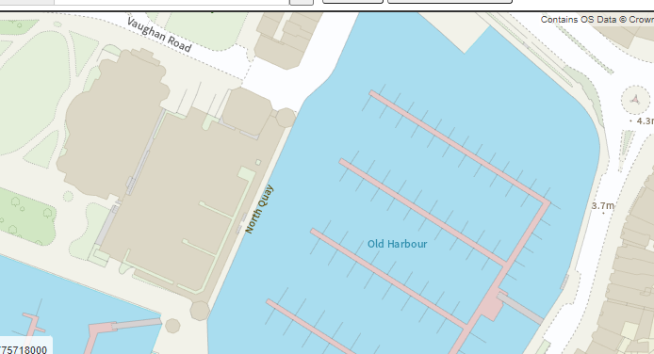

Allocation or HELAA Reference no. | 21T139
Approx. yield | 40
Suitable: How the principle of development is established | Torquay Harbour Conservation Area. Adjacent Pavilion is a grade 2 listed building and there are other listed buildings and a Registered Park/Garden in the vicinity. Application/2015/0961 and P/2015/0962LBC. However, the site is a sustainably located, key waterfront location.  P/2015 is for a 4/5 storey hotel and 7 storeys of residential= 43 units.  Located within flood zone 3 and an area at significant risk should a tidal flooding event occur – update of SFRA would provide more detail on whether this risk has worsened.
Available: Any change in circumstances since principle established | Council owned site. The application has had a troubled history and was quashed following judicial review. However, unless sistainably loated brownfield sites are pursued, there will be more pressure on greenfield development.
Achievable | See above- there are obstacles relating to heritage assets, marine conservation and parking (Cary Green being a Local Green Space).
Customer Reference no.
Current use | Car park
Site description | MDL car park and offices on the western side of Torquay Inner Harbour.
Total site area (ha) | 0.38ha

AVAILABILITY ASSESSMENT
Well located brownfield site. Significant heritage, LGS and marine ecology/SAC constraints. Previous application quashed following legal challenge. Likely to be a longer term site unless concerted action is taken to expedite.
The next 5 years
A 6-10 year period
An 11-15 year period | 40
Later than 15 years

