SITE OVERVIEW Amber- significant constraints
Town | Torquay
Site Name | Stantor Barton
HELAA Reference no. | 21T137
Approx. yield | 300
Suitable | Northern part of the site (adjacent Totnes Road may be more suitable. Distance from local services is a concern in terms of sustainability. Rejected in the 2013 SHLAA
Available | Does not appear to be available.
Achievable | Uplift in value would be likely to make development viable. However the land is not flat which will reduce the viability for affordable housing and other s106 obligations.
Customer Reference no.
Source of Site (call for sites, Local Plan allocation etc.). | Knowledge site
Current use | Agriculture
Site descriptions | Open fields to the west of Torquay and the east of Hellevoetsluis Way (Torquay Ring Road). The small hamlet of Stantor Cottages is accessed via a narrow lane. The land is part of a wider valley system and not flat.
Total site area (ha)
Gross site area (ha) | 10.1ha
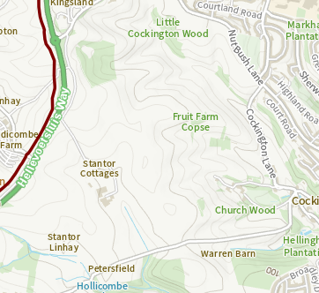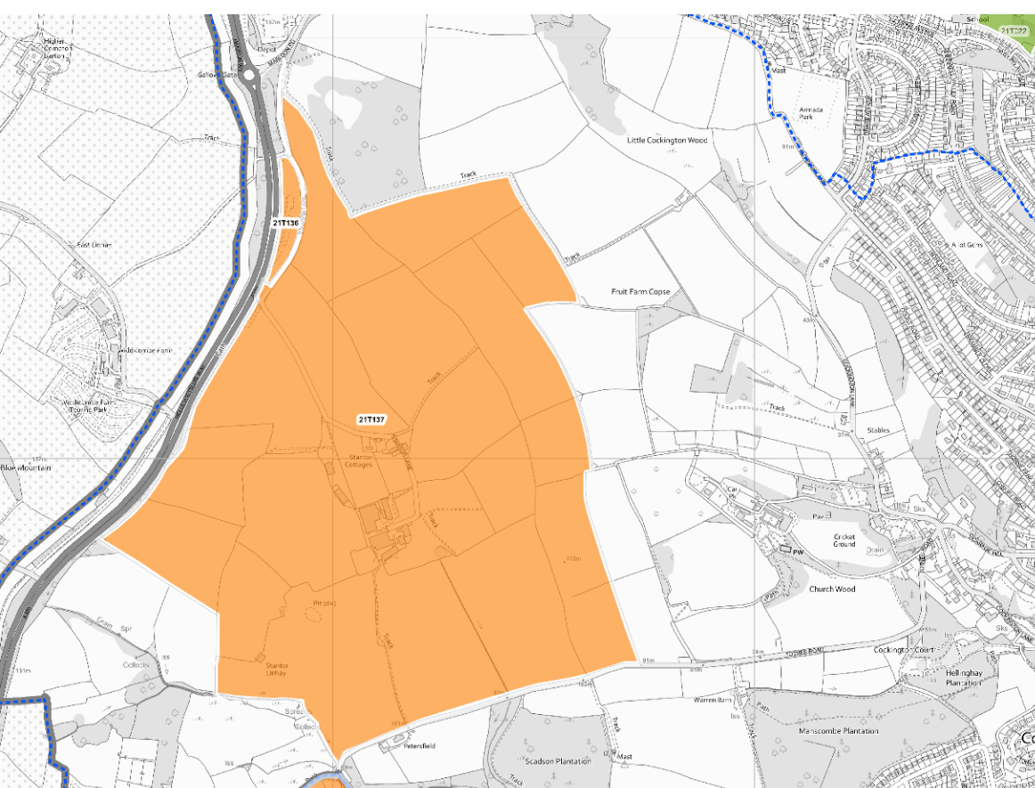

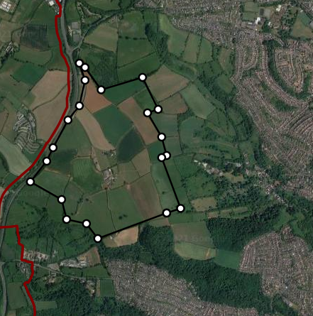

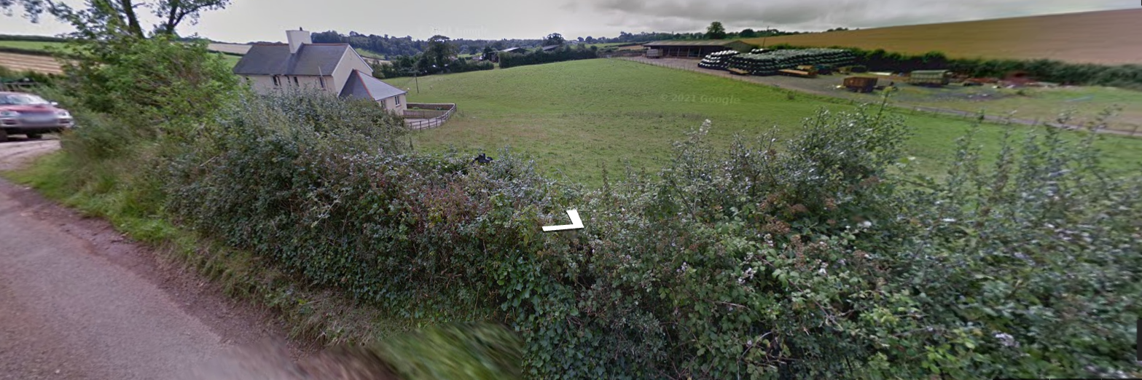

SUITABILITY ASSESSMENT: STAGE A

Strategic potential: | Yes
Housing? | Yes
Employment? | Employment would be required as part of a mixed use development.
Other Use? | Neighbourhood Centre (if developed as a mixed use area).
Biodiversity- Within SAC/SSSI | Agricultural land with some cottages:
Flood Zone 3b | No
Other NPPF Showstoppers (not policy constraints) | No
Conclusion | Distance from services and landscape impact are concerns. Potential biodiversity and archaeological issues. The site would need detailed further assessment and master planning.  Topography may limit viability.

SUITABILITY ASSESSMENT: STAGE B
Access | Easy access to main Ring Road e.g. via Gallows Gate or Hellevoetsluis Way. However, access to shops and other facilities is more difficult.
Flood risk, water quality and drainage | Not significant. The site would need servicing as it is distant from the built up area.
Heritage and Archaeology (including distance from assets). | Archaeology: Site includes Bronze Age funerary site. Also medieval manor/farmstead. Requires pre-determination assessment and evaluation to inform design and programme of archaeological mitigation.
Infrastructure | Distance from the built up area. Likely to need significant servicing.
Landscape | Rolling farmland 1E Upper Cockington (Highly sensitive: conserve and enhance) and 1FStantor Barton; Highly sensitive: enhance.  The site may be visible from Hay Tor.  The area of search is bounded to the north and south by LGS and would impact on them.
Ecology | Cirl Buntings and Greater Horsehoe bat Sustenance Zone. Local Nature Reserve and SSSI may be affected by development: amphibians
Safety related constraints | No
Soils (Agricultural Land classification) and contamination | Agricultural land (BMV)
Local Plan | C1 Countryside Area
Neighbourhood Plan | TLGSC3 and TLGSC11 to the north, east and South (may cover the more ecologically sensitive areas).
Development progress (where relevant) | No
Other
HELAA Panel Summary | Supported by panel - but may not be available.  The potential for cirl buntings and the related impact on viability was noted.  Would be a significant contribution to housing delivery including affordable.  Should only be allocated if the landowner is clearly willing.  Potential for new access onto dual carriageway, although this would be expensive.  Topography: If parts of the site are steeper than 1:5 or 1:6 then viability for affordable housing may become more challenging.  The impact of Biodiversity Net Gain should be considered when setting gross to net ratios and densities for a site like this.
Site potential | 300 however detailed assessment would be needed- topography may limit numbers.

AVAILABILITY ASSESSMENT
Not thought to be currently available. Even if being promoted a significant amount of further assessment would be needed. However the site is probably the largest greenfield area in Torquay not subject to NPPF “Footnote 7 ” constraints.
The next 5 years
A 6-10 year period
An 11-15 year period
Later than 15 years | 300

